TROY AREA
HIGH SCHOOL

EDUCATION
THE PATH OF OPPORTUNITY

2024-2025

SCHEDULING HANDBOOK

PARENTS/GUARDIANS

The curricula offerings at Troy High School are reviewed and revised each year to meet the changing needs of students and society. Your interest and cooperation in preparing your child’s schedule for 2024-2025 will, therefore, possibly be one of the most important activities you complete together this year. The choices you make will impact on your child’s opportunity for further education and future work choices. The staff and administration at Troy High School are committed to providing each student with the best educational program and are available to provide you and your child assistance in reaching that goal. Please feel free to contact any of the staff and administrators listed if you have any questions. Best wishes for a great 2024-2025 school year.

Troy Administration

SCHEDULING
Each spring all students have an opportunity to select courses appropriate to their needs and future plans. An evening program is held to review the program of studies. Members of the counseling department will be meeting with students to discuss their course selections for next year and individual student planning conferences are available. Students are constantly encouraged to involve their parents in the course selection process. In May, a master schedule is finalized for all high school students. After this time, schedule changes become extremely difficult because teachers, supplies, books and classroom spaces and class sizes have been arranged based on the courses students have selected. Therefore, schedule changes will be limited and only made for valid academic reasons. All schedule change requests must be made before the first day of school. Please consider all decisions carefully.

TABLE OF CONTENTS
TAHS GRADUATION REQUIREMENTS 1
STATE GRADUATION REQUIREMENTS 1
GRADE LEVEL CLASSIFICATION 5
EDUCATIONAL PATHWAYS 5
COURSE SELECTION 5
COURSE LOAD 6
DUAL/CONCURRENT ENROLLMENT 6
ADVANCED PLACEMENT (AP) COURSES 6
STUDY HALLS 6
COURSE/SCHEDULE CHANGES 6
ACADEMIC ELIGIBILITY FOR ACTIVITIES, CLUBS, SOCIETIES, ORGANIZATIONS, AND ATHLETICS 7
NCAA ELIGIBILITY RULES 7
TROY AREA JR SR HIGH SCHOOL’S NCAA APPROVED COURSES 16
SECONDARY EDUCATION OPTIONS 16
CAREER AND COURSE PLANNING RESOURCES 17
COURSE PLANNING SHEET 18
HOLLAND CODES 19
ASSESS YOURSELF 20
CAREER CLUSTERS 21
SUGGESTED COURSE SEQUENCE – AG, FOOD & NATURAL RESOURCES 24
SUGGESTED COURSE SEQUENCE – ARTS, COMMUNICATIONS, & INFO SYSTEMS 25
SUGGESTED COURSE SEQUENCE – BUSINESS, MANAGEMENT, & ADMINISTRATION 26
SUGGESTED COURSE SEQUENCE – ENGINEERING, MANUFACTURING, & TECH (STEM) 27
SUGGESTED COURSE SEQUENCE – HEALTH SCIENCE TECHNOLOGY 28
SUGGESTED COURSE SEQUENCE – HUMAN SERVICES 29
COURSE DESCRIPTIONS 30
ENGLISH DEPARTMENT 30
SOCIAL STUDIES DEPARTMENT 34
MATH DEPARTMENT 37
SCIENCE DEPARTMENT 40
BUSINESS DEPARTMENT 45
LANGUAGE DEPARTMENT 46
ART DEPARTMENT 47
FAMILY AND CONSUMER SCIENCE 48
MUSIC DEPARTMENT 49
PHYSICAL EDUCATION AND HEALTH 50
FUTURE READY 52
TECHNOLOGY EDUCATION DEPARTMENT 53
AGRICULTURE DEPARTMENT 55
NORTHERN TIER CAREER CENTER 59

TROY AREA HIGH SCHOOL GRADUATION REQUIREMENTS:
Graduating Classes of 2025 and beyond:
English 4.00
Mathematics 4.00
Science 3.00
STEM (Technology, Science, or Math) 1.00
Social Studies (American History, World Cultures, US Civics and Government) 3.00
Arts and Humanities (Art, Music, Languages, Social Sciences) 2.00
General Electives 6.00
Physical Education 1.00
Health 0.25
Career Exploration 0.25
Financial Literacy 0.25
Activities for Life 0.25
_____________________________________________________________________________________________
Total Required Credits: 25.00

STATE GRADUATION REQUIREMENTS
In addition to these requirements, the Graduating classes of 2023 and beyond must also meet the state requirements for graduation by completing one of the following 5 Pathways to Graduation. These pathways are defined in the graphic on the next page.
- Keystone Proficiency Pathway
- Keystone Composite Pathway
- CTE Concentrator Pathway
- Alternative Assessment Pathway
- Evidence Based Pathway
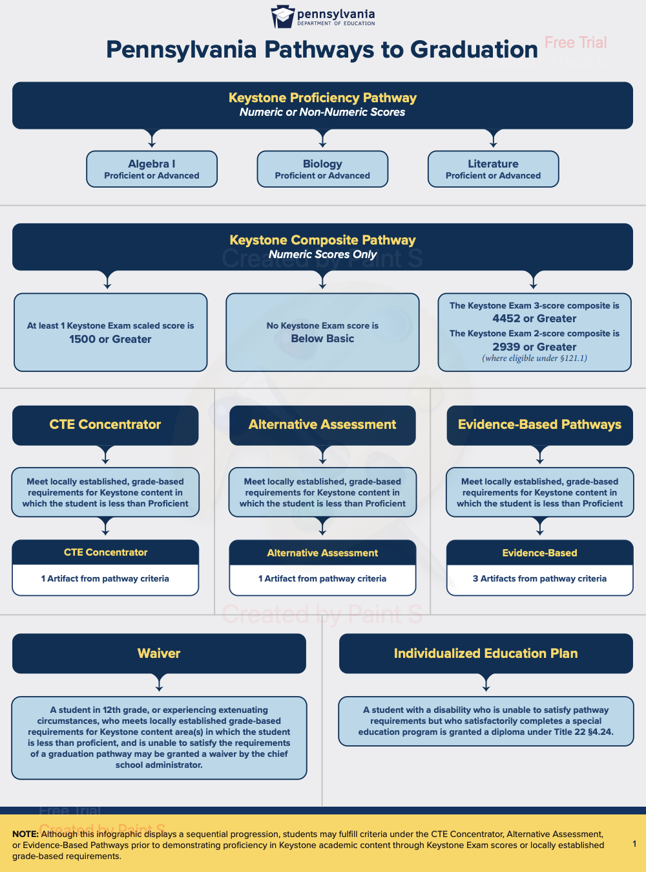
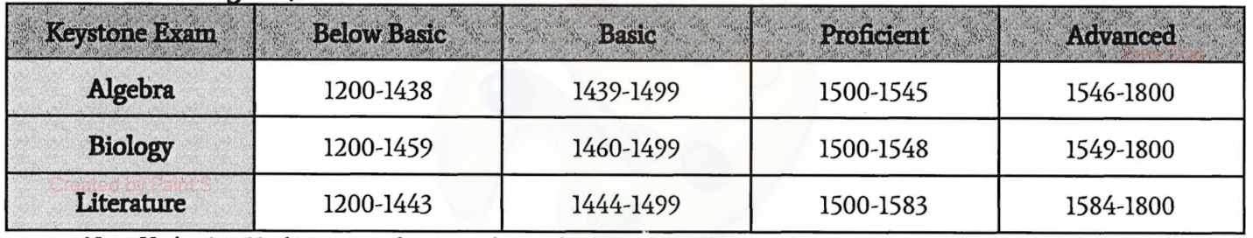
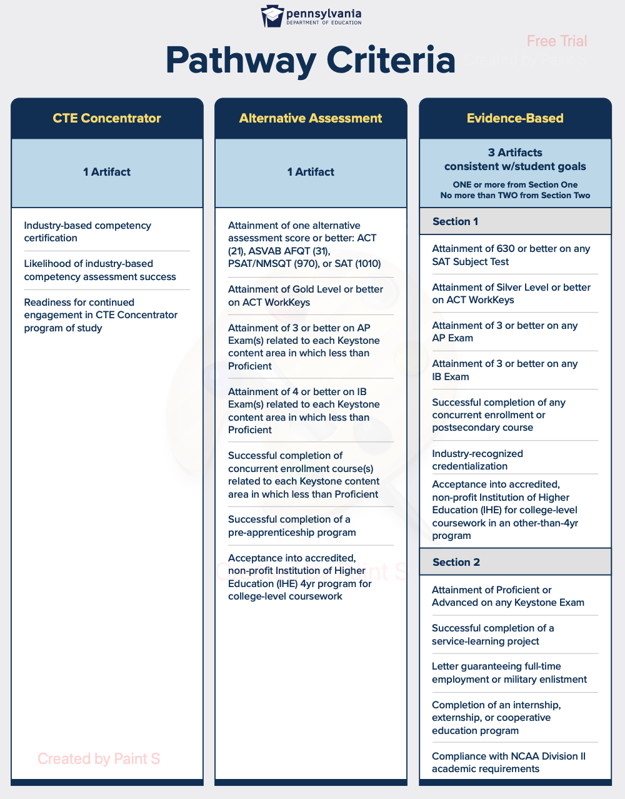

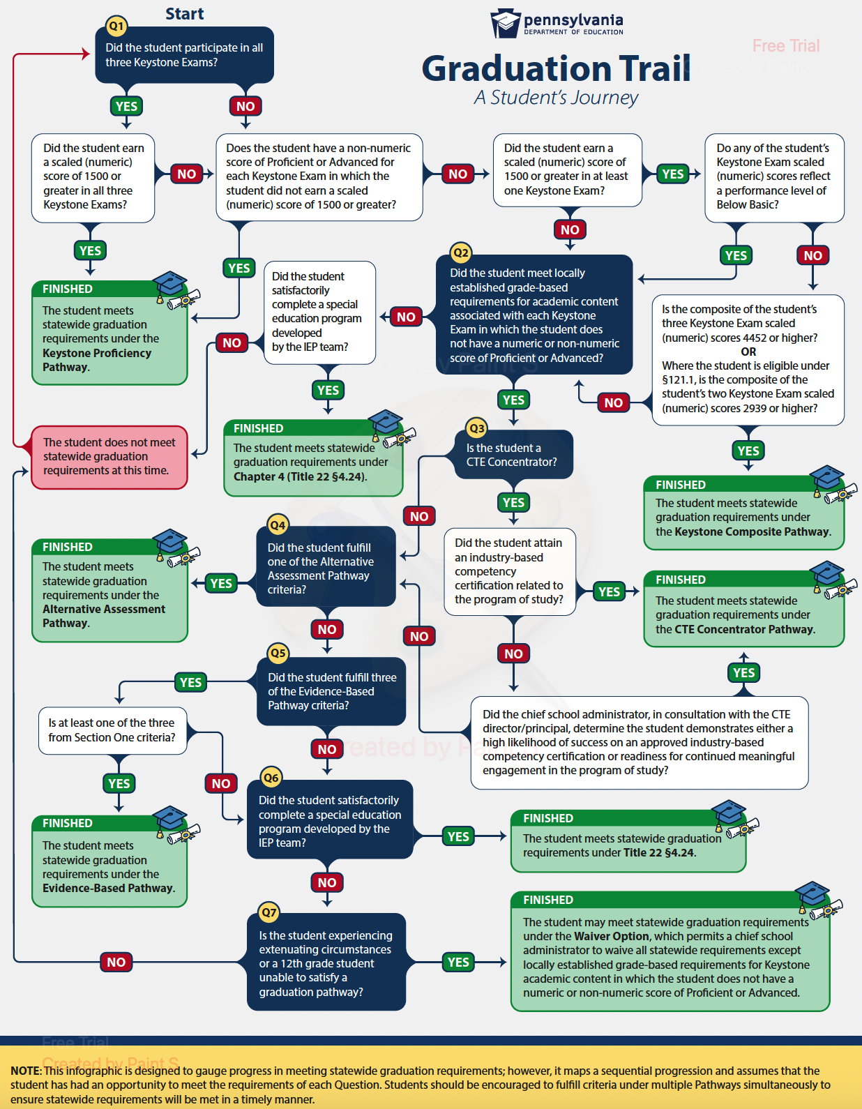

GRADE LEVEL CLASSIFICATION
The grade level in which you begin the year in September is the grade level you will remain for the whole academic year. It is in your best interest and STRONGLY ENCOURAGED to engage in some type of credit recovery during the summer if you are behind in credits.
10th grade – Students must earn 6 credits their freshman year to be considered a sophomore.
11th grade – Students must earn 12 credits by the end of their sophomore year to be considered a junior.
12th grade – Students must earn 18 credits by the end of their junior year to be considered a senior.
Graduate – Students need a MINIMUM of 25 credits in the areas addressed above in order to be a candidate for graduation. Students will also need to meet one of the state required graduation pathways defined above to be eligible to graduate.

EDUCATIONAL PATHWAYS
The Educational Pathways program is both a process and a structure providing comprehensive information and guidance so students can make informed decisions in career planning and educational course selections.

Starting in eighth grade, the Troy Area School District encourages students to think seriously about their futures and plan an educational program that will provide the necessary knowledge and skills to succeed.

Students learn about current trends in career development and make tentative choices about a chosen career. Then they review courses that make the choice a reality. Long-term career development encourages students and parents to make course selections based on student aptitudes, interests, developed skills, and current career information. Because of this new direction, students must consider curriculum selections and career choices together. Students and school counselors annually review these decisions.

It is a win-win situation for all stakeholders: students, parents, funding sources, community, and faculty. Because parents and students are active participants in the process, constant communication is vital. Students may engage in work-based learning activities such as job shadowing, co-op, and work experiences.

Please see the Career and Course Planning Resources section later in this handbook for assistance in career planning and course scheduling.

COURSE SELECTION
You may take any course appropriate to your ability and interest. We suggest that you carefully follow the recommended prerequisites and program of studies for your educational pathway. Any student who would like to take any course, but does not meet the recommended prerequisites, must have parents sign a waiver form requesting enrollment in that course.

Most courses must have a minimum of 10 students in order to “run” here on campus. Administrator discretion will be used for higher level academic courses which do not have 10 requests. For courses that do not have enough requests and/or scheduled students.
If this course is not a credit recovery situation for a student, the online option will be at no cost to the student as long as the student needs the course for credit to graduate. However, if the course is not needed for graduation credit, then the student will be required to pay a deposit of 50% of the course cost (varying based on course and online provider) prior to starting the course. If the student successfully completes the course with a passing grade by the end of the quarter or semester, the student will be fully reimbursed the deposit. However, if a student does not successfully complete the course with a passing grade by the given deadline, the student will be required to pay the remaining balance of the course.
If the course is needed for credit recovery, the student/family will be responsible for covering the cost of the online course which will vary depending on the mode of delivery, course, and possible online provider.

COURSE LOAD
It is recommended that all Troy students carry 7 or 8 credits each school year.

DUAL/CONCURRENT ENROLLMENT
Courses may be available to college-ready juniors or seniors interested in receiving both high school and college credit. In order to receive college credit, juniors or seniors must meet certain academic requirements and complete an application process. Courses offered at Troy High School which may also be taken for college credit are: Speech, Honors English 12, AP English Literature and Composition, Anatomy and Physiology I, Anatomy and Physiology II, AP Chemistry, Physics II, AP Statistics, Mathematical Reasoning and Application (College Prep Math), AP Calculus, Web Design, Honors Sociology, and Honors Psychology. (Courses offered are subject to change based on teacher availability and qualifications.) Please call your child’s School Counselor for more information.
There are other opportunities to take college courses. Students should see their counselor in the Spring of their sophomore year to discuss these possibilities.

Additionally, we participate in Mansfield University’s ESP Program. This program allows students to earn college credits for free, with the option of also using these credits as high school credits, by taking online classes through Mansfield University. Throughout the year the Guidance Office will be made aware of the selected courses being offered for each term: Fall Semester, Spring Semester, and Summer Session I and II. Students will need to apply, get a letter of recommendation from a school counselor, and register. Course registration is on a space-available basis.

ADVANCED PLACEMENT COURSES
Students enrolled in an AP course will be required to take the AP exam at the end of the course. There is a fee associated with each AP exam. The district, using funds received from the Troy Foundation Mini Grant program will reduce the cost of the AP exams for each student. The amount reduced will depend upon the number of exams being taken in a school year and a student’s free/reduced lunch status. If a student does not take the AP exam, the student will be fully responsible for the unused exam fee assessed by the College Board.

STUDY HALLS
It is highly recommended that students have only ONE period of study hall each day. Students engaging in Mansfield ESP classes (or other online dual enrollment courses) may schedule a study hall for each online class for which they are enrolled. Students should replace additional study halls (if applicable) with an onsite class they have not previously passed.

COURSE/SCHEDULE CHANGES
Changes to a selected course may be made through the student’s counselor until one week prior to the first day of school. Before the first day of school, changes will be made only for the following scheduling issues: (1) scheduling error; (2) scheduling conflicts (3) academic misplacement. No other changes will be considered unless they are of an extreme circumstance. Final scheduling decisions are subject to the discretion of the counseling and administrative team.

Following the first 10 days of the course, a student may not drop a course without administrative approval. Dropping a course after this time will result in an “Incomplete” grade on the student’s transcript.

Drop/Add Request Period
All schedule change requests made in the first 10 days of school will require the use of the Drop/Add form. All completed Drop/Add request forms must be submitted to the guidance office no later than September 4, 2024.

Summer Schedule Change Requests
Summer Schedule Change Requests must be made through the Guidance Office. Student, parent, school counselor and administrative (principal/assistant principal) input will be considered. Requests may be made via e-mail, a written request, by phone, or in person. If you need to leave a voice mail, please call:
Mrs. Brands – 570-297-2176 x5305 (Guidance Department Secretary)
Dr. Bellinger – 570-297-2176 x5306 (School Counselor)
Mrs. Stevens – 570-297-2176 x5307 (School Counselor)
ALL summer schedule change requests MUST be completed NO LATER than Wednesday, August 14, 2024 (1 week prior to the first day of school).
Summer Hours: Offices are open Monday through Thursday, 8:00 AM – 3:00 PM. All district buildings will be closed on Fridays throughout the summer.
Options for Failed Courses
- Reschedule courses for the next school year.
- Summer school course credit and/or online credit recovery options are available at a cost to the family. Details will be available through the guidance office. Summer school courses may also be available from nearby school districts. Contact the Guidance Office for information.
Deadlines provided by the Guidance Department MUST be followed. Students not submitting course selection paperwork, summer schedule change requests, or drop/add requests by stated deadlines run the risk of not getting courses they request, being assigned to courses they did not ask for, and/or having a schedule created for them.

ACADEMIC ELIGIBILITY FOR ACTIVITIES, CLUBS, SOCIETIES, ORGANIZATIONS, AND ATHLETICS
Please see the TAHS Student handbook for all eligibility requirements.

NCAA ELIGIBILITY RULES
The advantages of competing in college sports are both immediate and lifelong. Participating in college sports provides opportunities to learn, compete and succeed. Student-athletes receive top-notch academic support, quality medical care and regular access to outstanding coaching, facilities, and equipment. Student-athletes as a group graduate at higher rates than their peers in the general student body and feel better prepared for life after college.
College-bound student-athletes preparing to enroll in a Division I or Division II school need to register with the NCAA Eligibility Center to ensure they have met amateurism standards and are academically prepared for college coursework.

What is the NCAA Eligibility Center? Why is it Important?
The NCAA Eligibility Center took over operations for the NCAA Initial-Eligibility Clearinghouse in November 2007. The Eligibility Center certifies the academic and amateur credentials of all students who want to play sports at an NCAA Division I or II institution as freshmen. In order to practice, play and receive an athletics scholarship, students need to meet certain academic benchmarks. An additional certification process exists to make sure the student is still an amateur, which is necessary in order for the student to compete collegially.

Academic Credentials + Amateurism Status = College Eligible

Are you ready to play college sports?

Play Division I Sports
Division I schools, on average, enroll the most students, manage the largest athletics budgets, offer a wide array of academic programs and provide the most athletics scholarships.

Play Division II Sports
Division II schools provide growth opportunities through academic achievement, high-level competition and a focus on community engagement.

Play Division III Sports
Division III schools provide an integrated environment focusing on academic success while offering a competitive athletics environment. If you are planning to attend a Division III school, you do not need to register with the NCAA Eligibility Center.

What are the Academic Initial-Eligibility Requirements?
The following requirements must be met for a student to be able to practice, play, and receive a scholarship at an NCAA Division I or II college or university.

Division I
- Graduate from high school;
- Complete a minimum of 16 core courses;
- Present the required grade-point average (GPA) (see the sliding scale in the Guide for the College-Bound Student-Athlete for Division I); and
- Complete the amateurism questionnaire and request final amateurism certification.

Division I Core-Course Breakdown (Courses Must Appear on your List of Approved Core Courses)
- 4 years of English
- 3 years of math (Algebra I or higher)
- 2 years of natural or physical science (including one year of lab science if offered by your high school)
- 1 extra year of English, math, or natural or physical science
- 2 years of social science
- 4 years of extra core courses from any category above, or foreign language, nondoctrinal/comparative religion/philosophy

Division II
- Graduate from high school;
- Complete a minimum of 16 core courses;
- Present a minimum 2.2 core-course grade-point average (GPA.
- Complete the amateurism questionnaire and request final amateurism certification.

Division II Core-Course Breakdown: (Courses Must Appear on your List of Approved Core Courses)
- 3 years of English
- 2 years of math (Algebra 1 or higher)
- 2 years of natural or physical science (including one year of lab science if offered by your high school);
- 3 additional years of English, math, or natural or physical science
- 2 years of social science
- 4 years of extra core courses from any category above, or foreign language, nondoctrinal/comparative religion/philosophy

Core Courses
NCAA schools require college-bound student-athletes to build a foundation of high school courses to prepare them for the academic expectations in college. The list of Troy’s NCAA courses are listed below.

What are core courses?
Not all high school classes count as NCAA core courses. Only classes in English, math (Algebra 1 or higher), natural or physical science, social science, foreign language, comparative religion or philosophy may be approved as NCAA core courses. Remedial classes and classes completed through credit-by-exam are not considered NCAA core courses.

If you take a high school class such as Algebra 1 or Spanish 1 before you start ninth grade, the class may count for your 16 core courses if it is on your high school’s list of approved core courses and is shown on your high school transcript with a grade and a credit.

Credit
You can earn credit for a core course only once. If you take a course that repeats the content of another core course, you earn credit for only one of these courses and the higher grade counts toward your core-course GPA.

Generally, you receive the same number of credits from the NCAA for a core course that you receive from your high school for the class. One academic semester of a class counts for .5 of a core course credit. One academic trimester of a class counts for .34 of a core-course credit. One academic quarter of a class counts for .25 of a core-course credit. A one-year class taken over a longer period of time is considered one core course and is not awarded more than one credit. (Troy’s Keystone Biology or Honors Keystone Biology only counts as 1 core course credit for NCAA even though you receive 2 high school credits for the course.)

Division I additional core course
Division I schools allow you to complete one additional core-course unit after you graduate high school, as long as you graduate in eight semesters after you begin ninth grade. The additional core-course unit must be completed within one year after your high school graduation and must be completed before you enroll in college.

The additional core course unit may be taken at a different school than the high school from which you graduated as long as the class is on the new school's list of approved NCAA core courses. If you take the additional core course at a school other than the school from which you graduated, you must provide the NCAA Eligibility Center with an official transcript from the new school showing the additional core-course grade and credit.
If you take the additional core course through a program that does not award credit, the course must be awarded credit by a credit-awarding high school.

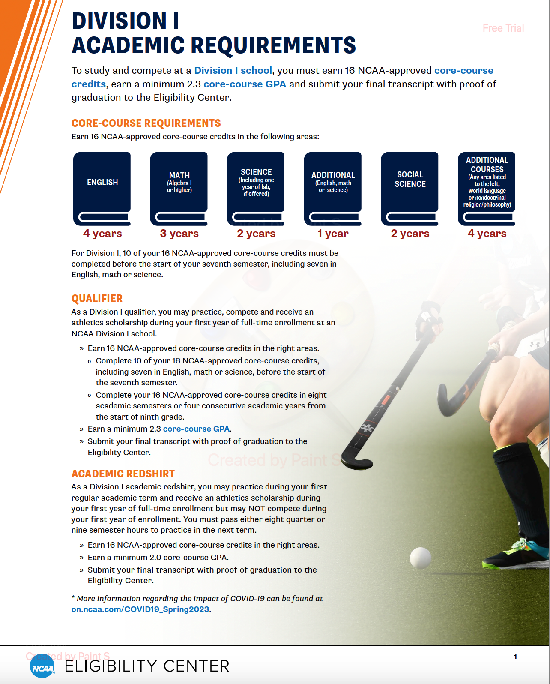

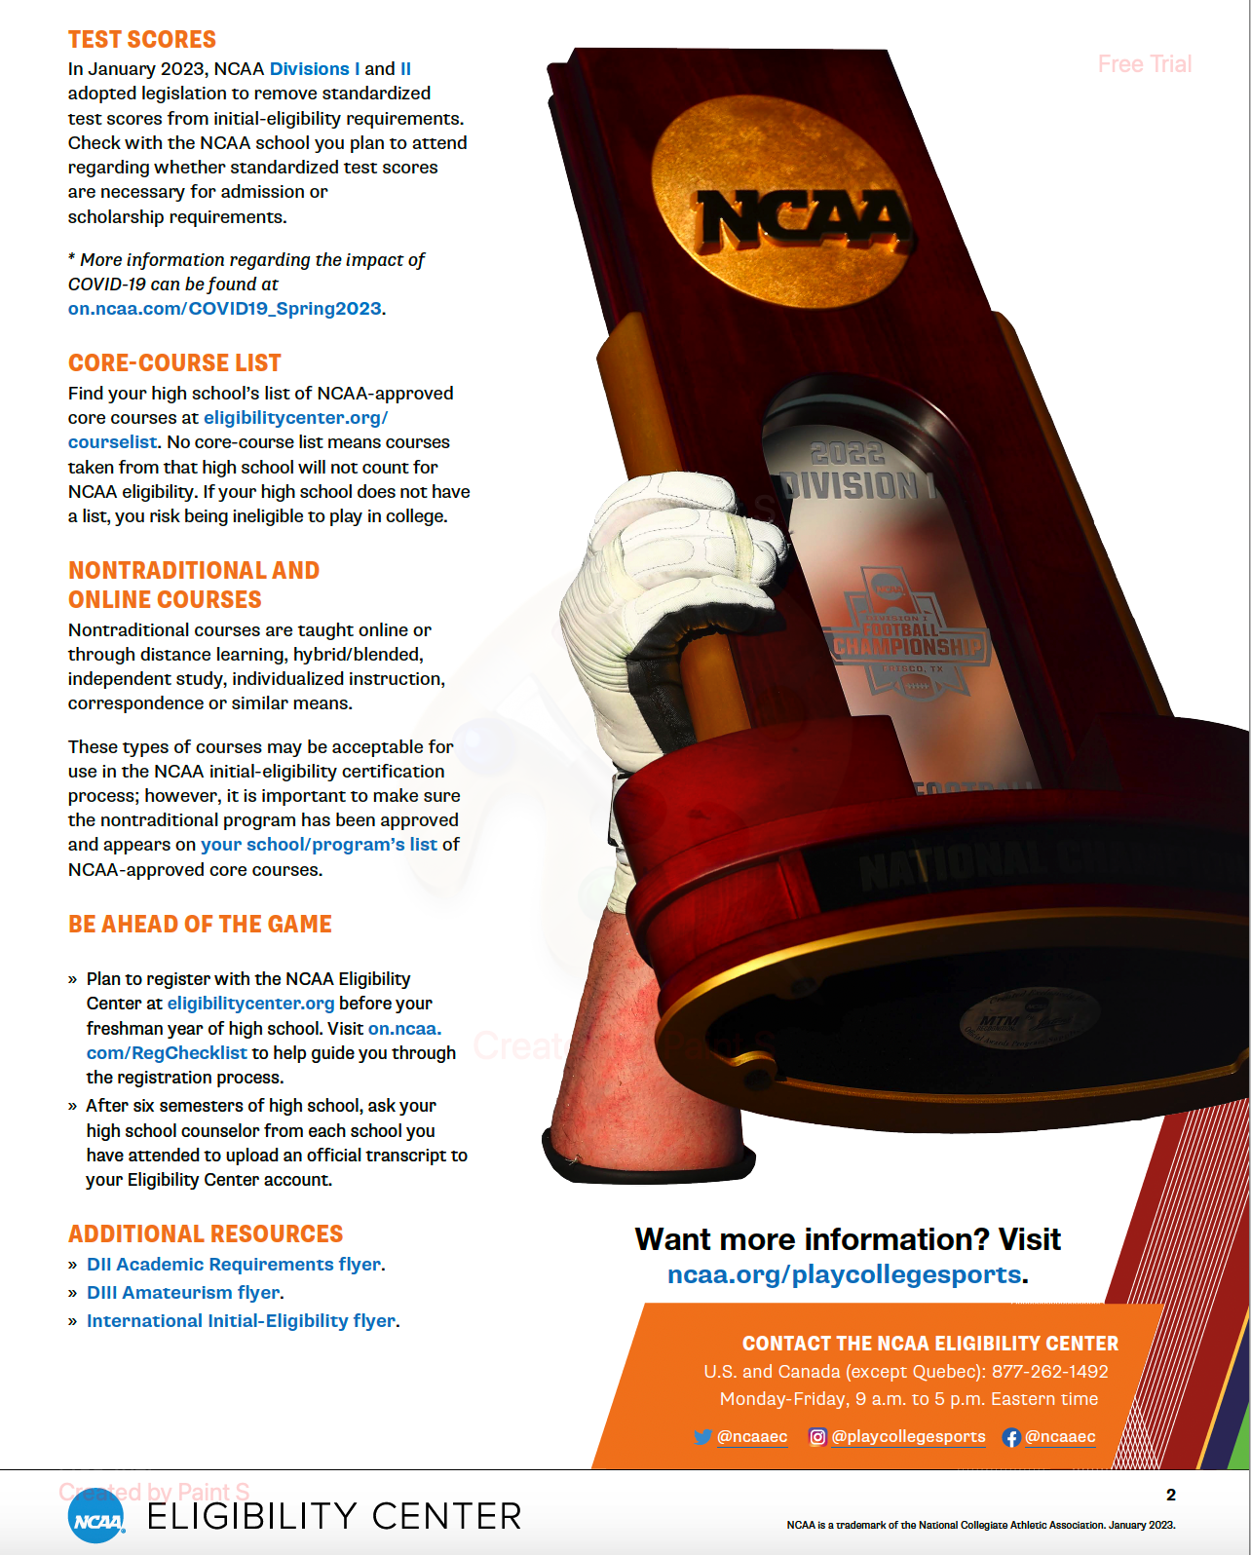

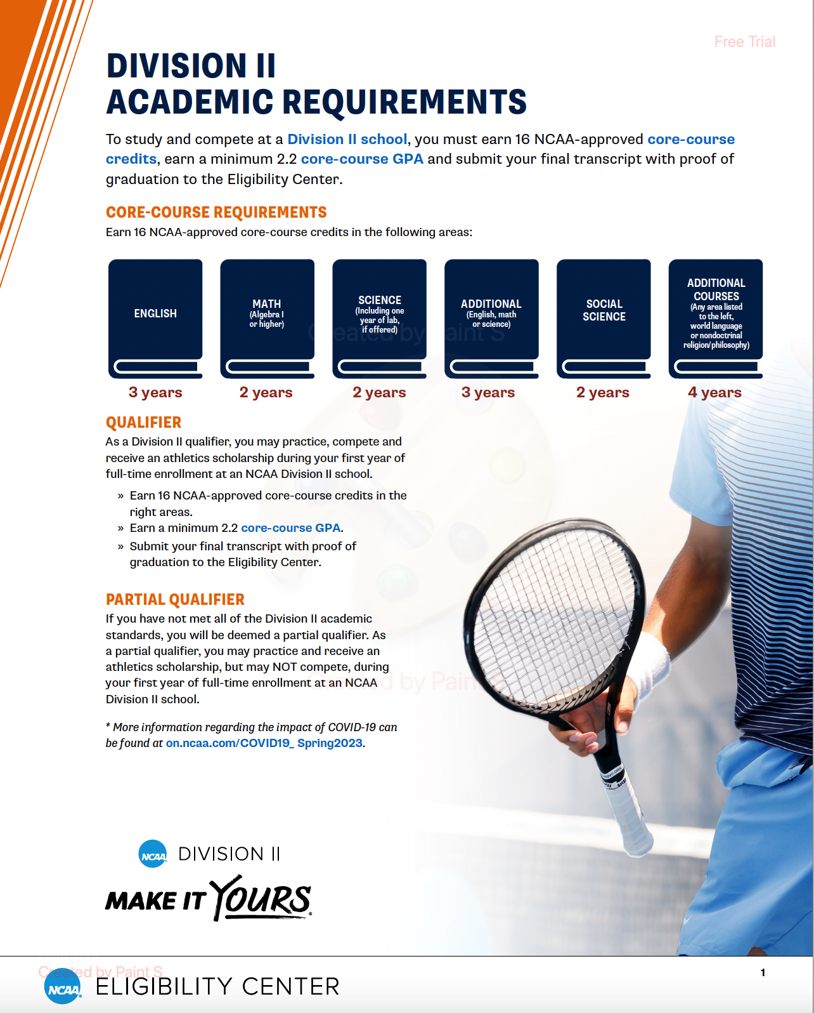

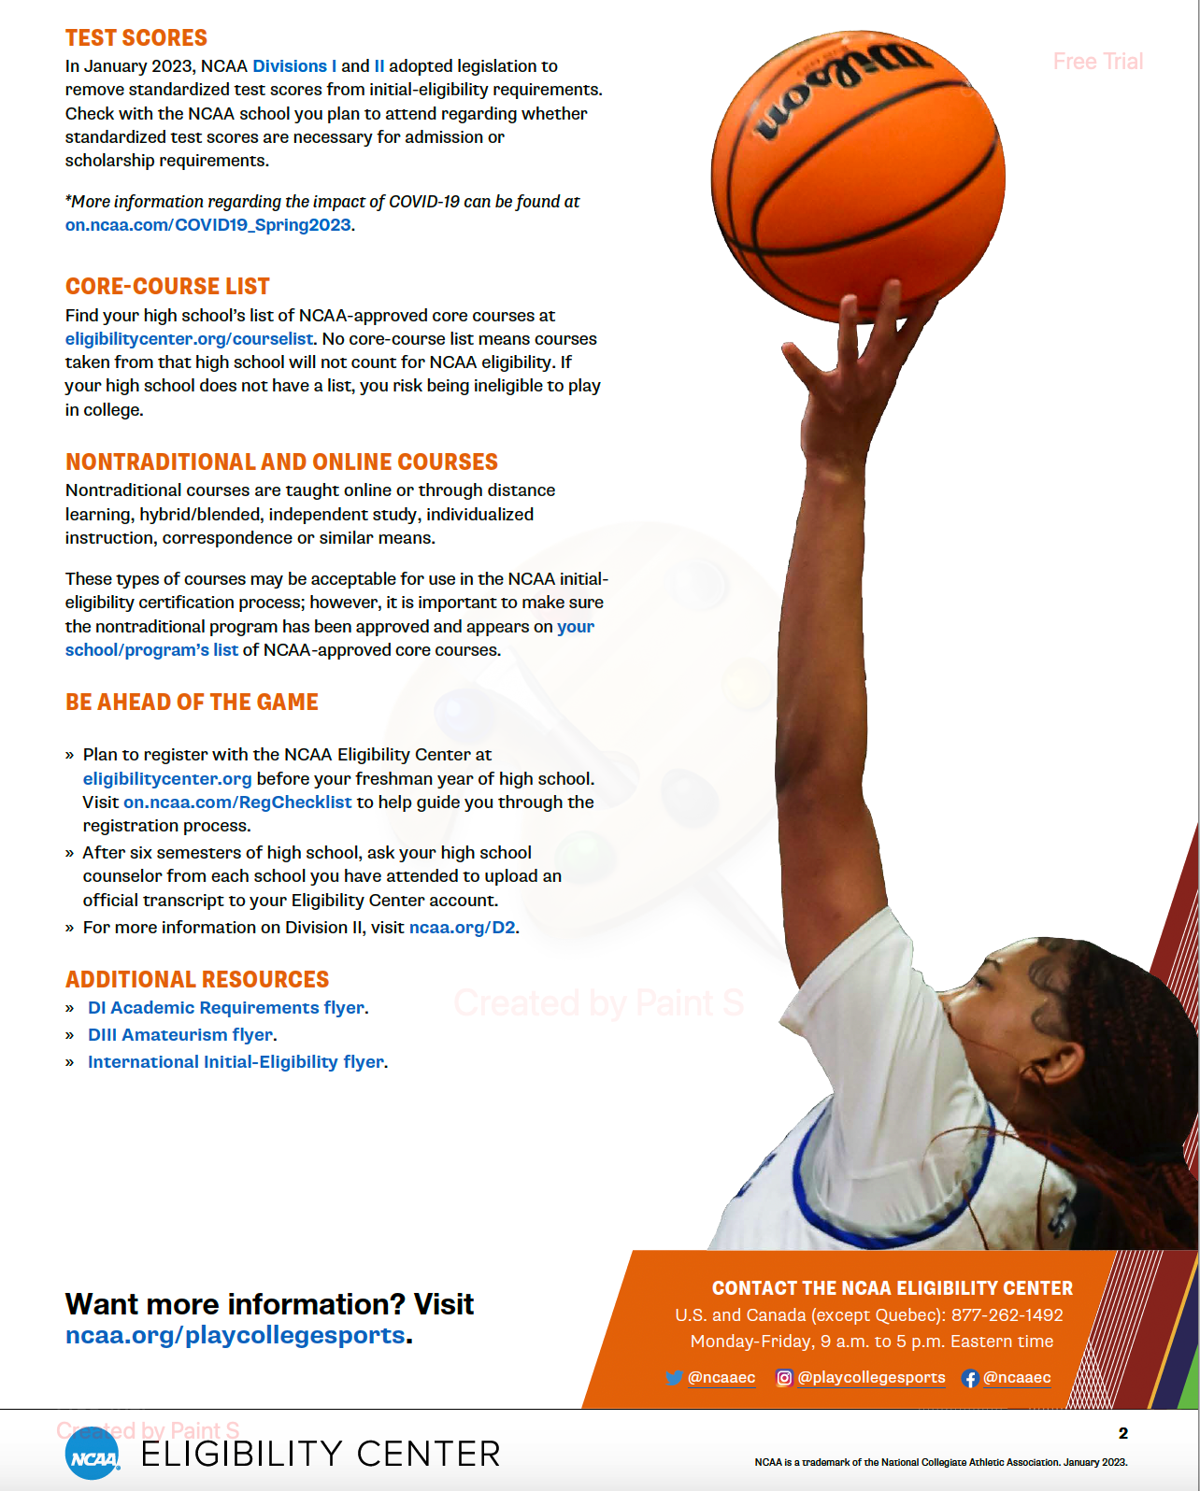

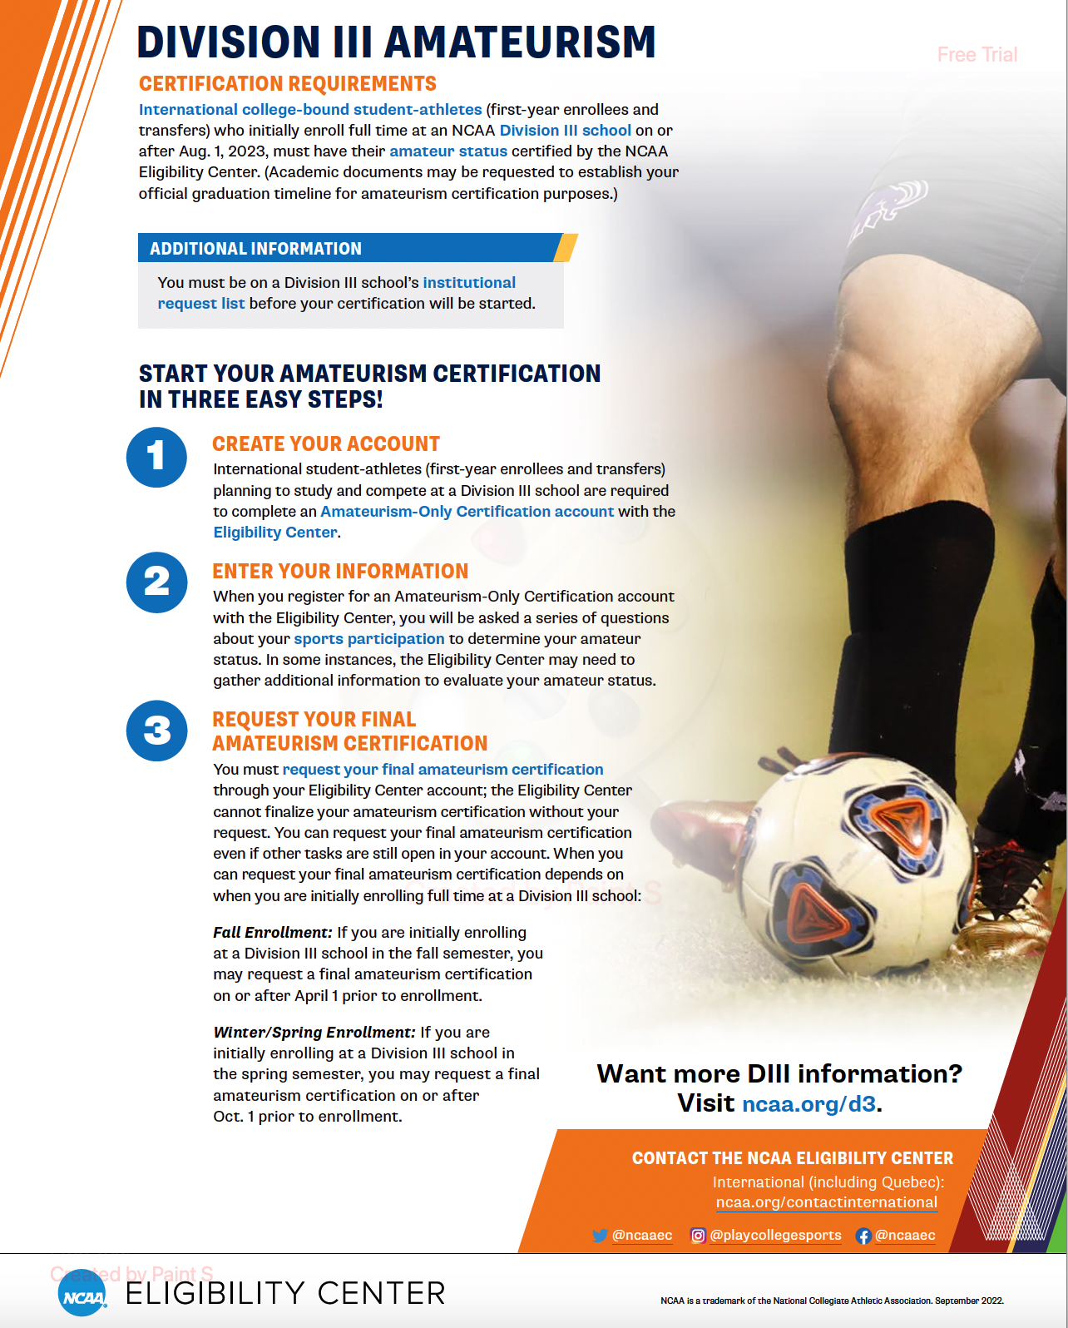

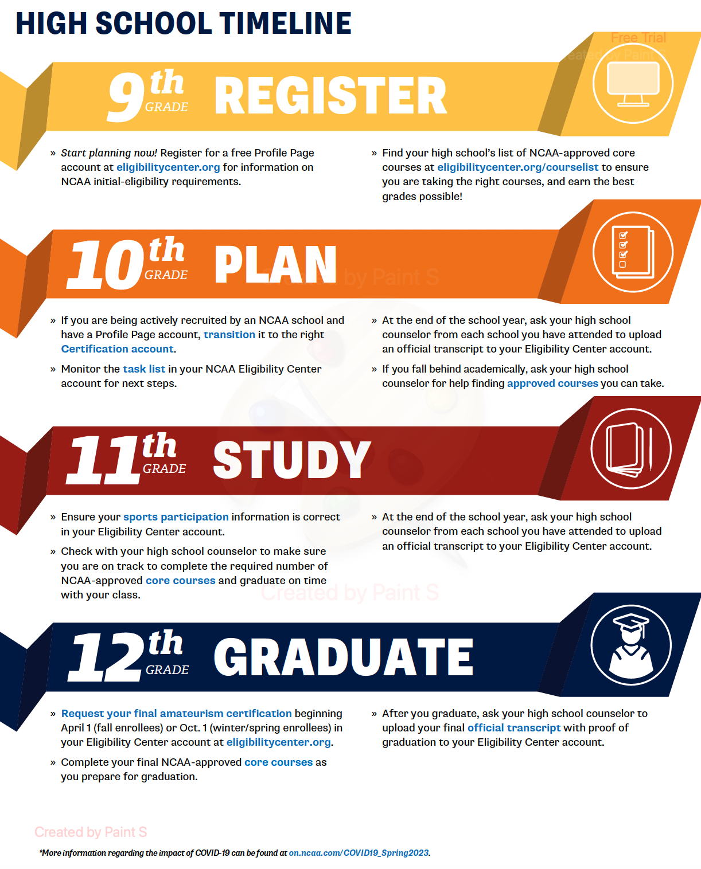

TROY AREA JR SR HIGH SCHOOL’S NCAA APPROVED COURSES

AP Language and Composition
AP Literature and Composition
Composition I
Creative Writing
English 11
Honors English 11
English 12
Honors English 12
Keystone English 10
Honors Keystone English 10
Keystone English 9
Honors Keystone English 9
Literature in the Land
Mythology
Speech
American History III-Progressive Era
Honors American History III-Progressive Era
American History IV-Modern Era
Honors American History IV-Modern Era
Business Law
Honors Psychology
Honors Sociology
Psychology
Sociology
US Civics & Government
Honors US Civics & Government
World Cultures
World Cultures Honors
World War II
Algebra 2

AP Calculus
AP Statistics
Calculus I
Geometry
Honors Geometry
Intro Statistics and Probability
Keystone Algebra I
Keystone Algebra I Module 1
Keystone Algebra I Module 2
Mathematical Reasoning and Applications
Pre-Calculus
Anatomy & Physiology I
Anatomy & Physiology II
AP Chemistry
Chemistry
Chemistry 2
Earth Science
Genetics
Honors Chemistry
Honors Keystone Biology
Keystone Biology
Microbiology
Physics I
Physics II
Physics III
Science in Society
Spanish 1
Spanish 2
Spanish 3
Spanish 4

SECONDARY EDUCATION OPTIONS
Troy High School
- All students are provided 1:1 technology to utilize as an instructional tool.
- Over 97 elective courses are available for students for career exploration.
- Students interested in pursuing Music have the ability to participate in Concert Band, Concert Choir, Marching Band, Troy’s musical productions, Music Appreciation, Music Theory, and many county and district festivals and competitions.
- On site dedicated Career Coach to guide students through the college and career selection process.
- Several Advance Placement courses and the ability to schedule any AP exam students are prepared to take.
- Varsity Sports and over 20 clubs and activities
- Potential to earn college credit while in high school through Articulation agreements and College in the High School

Troy Online Academy
- Self-Paced classes
- Multi-media rich, interactive courses
- District Diploma
- Accessible anytime, anywhere
- Free to TASD students
- PA-Certified Teachers Only
- Student activities available

Northern Tier Career Center (NTCC)
- Hands-on learning, project-based learning experiences offered in a variety of career and technical fields
- Opportunities for high-skilled, high wage occupations
- Opportunity to participate in student led organizations that support classroom learning
- Potential to earn college credit while in high school through Articulation agreements and College in the High School
- Industry based learning opportunities that can lead to certifications

CAREER AND COURSE PLANNING RESOURCES
Troy Area High School Career Pathways are designed to help focus student course selections and connect students to a viable career and/or post-secondary program of study. Each student will identify with one or more concentration areas based on individual interests and skills, post-secondary goals, and potential career aspirations. Over the next few pages, information regarding the aligned Holland codes and career clusters will help inform students and parents in course selection. In addition to accessing the Holland codes assessment via this handbook, students will also be exposed to different careers through lessons facilitated by the school counselors, career coach, and various classroom teachers at each grade level, as well as by utilizing the Smart Futures program.
Within each Career Pathway concentration area, potential career options and recommended courses will help students focus their course selections. Each pathway lists a few possible career options based on levels of post-secondary training identified as workforce, technical/skilled, and professional. These are defined below.
- Workforce careers: typically require a high school diploma, on-the-job training, or military training.
- Technical/skilled careers: typically require technical training, apprenticeships, and/or two (2) years of college (associates degree)
- Professional careers: typically require a minimum of four (4) years of college (bachelor’s degree)
WHICH OPTION SUITS YOU?
TYPE | DESCRIPTION
OJT (On-the-Job Training) | Employer-designed training established for the worker to gain the necessary work skills while he is getting paid on the job. Usually these will last weeks to months.
Military Training | All branches of the military have skilled training for 3 years or more. Students can use their GI Bill to pay for college after their discharge or serve for 20 years until retirement with full benefits.
Diploma or Certificate Programs | Short-term programs of 6 months to 1 year to gain specific skills to gain employment at the entry level. These can be found at technical schools, community colleges, junior colleges and even some universities.
Apprenticeship Programs | Industry-based program training workers on the job and in a classroom setting as well. Upon completion the worker will gain journeyman status in the specific industry (3–4 years in length). Apprentices are paid as they go to school.
Bachelor’s Degree Programs | These are four-year degrees with a combination of general education course work and a specific major. They can be liberal arts colleges, private colleges, public colleges or universities.
Graduate and Professional Degree Programs | These are the post-graduate fields such as law, medicine and Ph.D. or other professional fields, typically 1 to 5 years beyond the bachelor’s degree.

The Career Pathways listed in this handbook are aligned with widely recognized Career Clusters. Career Clusters are a way of grouping careers with common features and skills. Careers grouped into the same cluster typically require similar, yet varied, education and training. Exploring clusters can be a useful way to find a good career match, especially if you have general areas of interest but are not sure what specific careers match those interests. Career clusters can also help you better understand how your coursework in high school can prepare you for certain types of careers.
We believe students should exercise choice and flexibility, both within and among the pathways, to navigate a well-rounded foundation and experience a number of curricular options related to each specified career pathway. It is acceptable for students to explore a variety of content areas and interests. The designation of a particular concentration area is not meant to limit one’s choices. Instead, the suggested pathways provide a way to think about how course work in high school can be a springboard to future opportunities.

COURSE PLANNING SHEET
9th Grade | 10th Grade
English:  Math:  Science:  Social Studies:  STEM:  Physical Education:  Required: Career Exploration  Electives:  Other: | English:  Math:  Science:  Social Studies:  STEM:  Physical Education:  Required: Health  Electives:  Other:
11th Grade | 12th Grade
English:  Math:  Science:  Social Studies:  STEM:  Physical Education:  Required: Financial Literacy  Electives:  Other: | English:  Math:  Science:  Social Studies:  STEM:  Physical Education:  Required: Activities for Life  Electives:  Other:

What Are The…

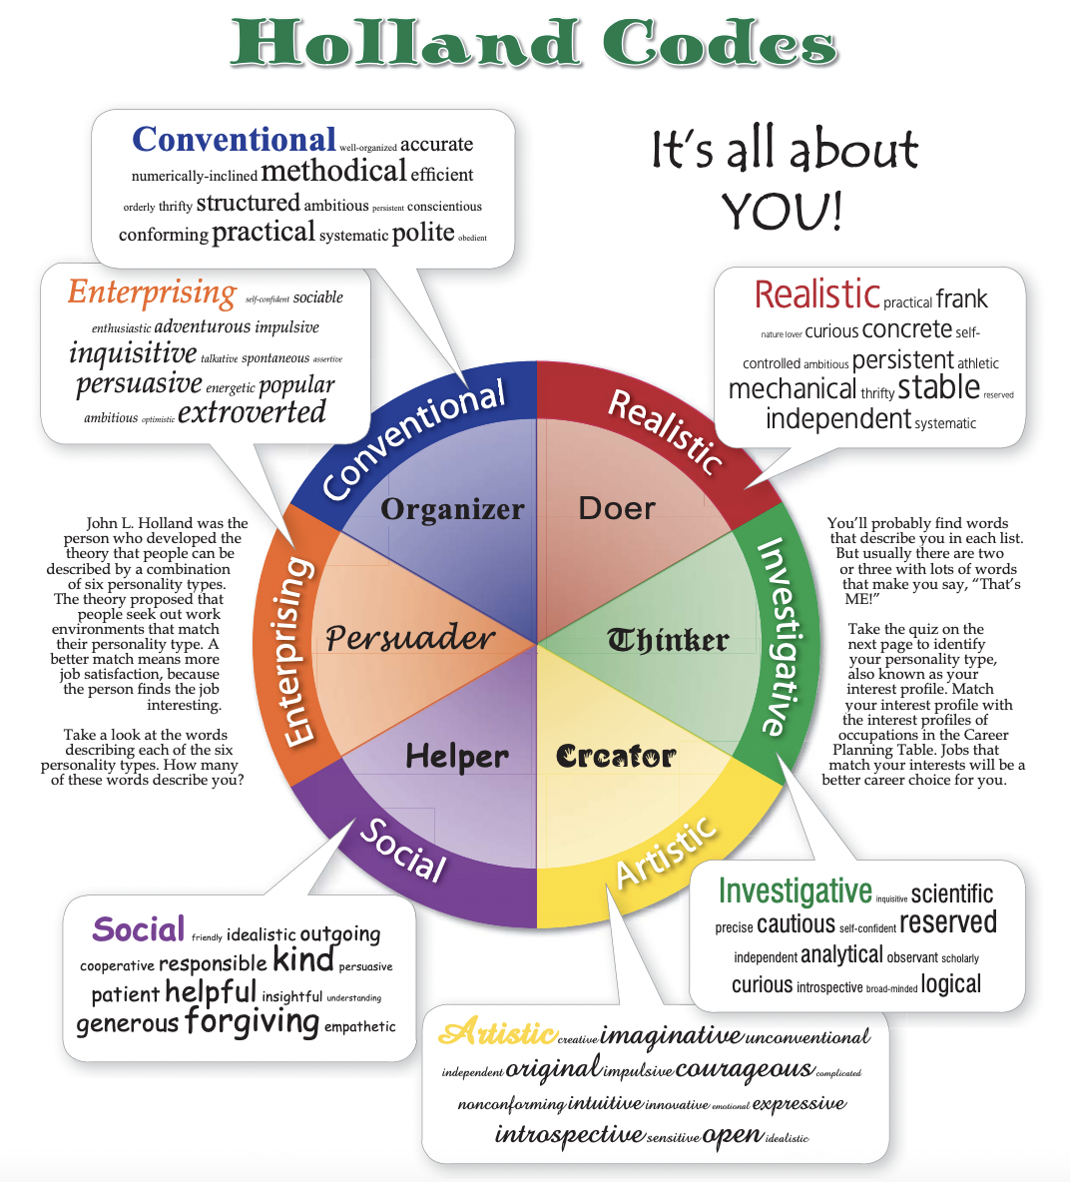
graphic accessed from: https://www.nhes.nh.gov/elmi/career/documents/holland-code-sparks.pdf

Assess Yourself…
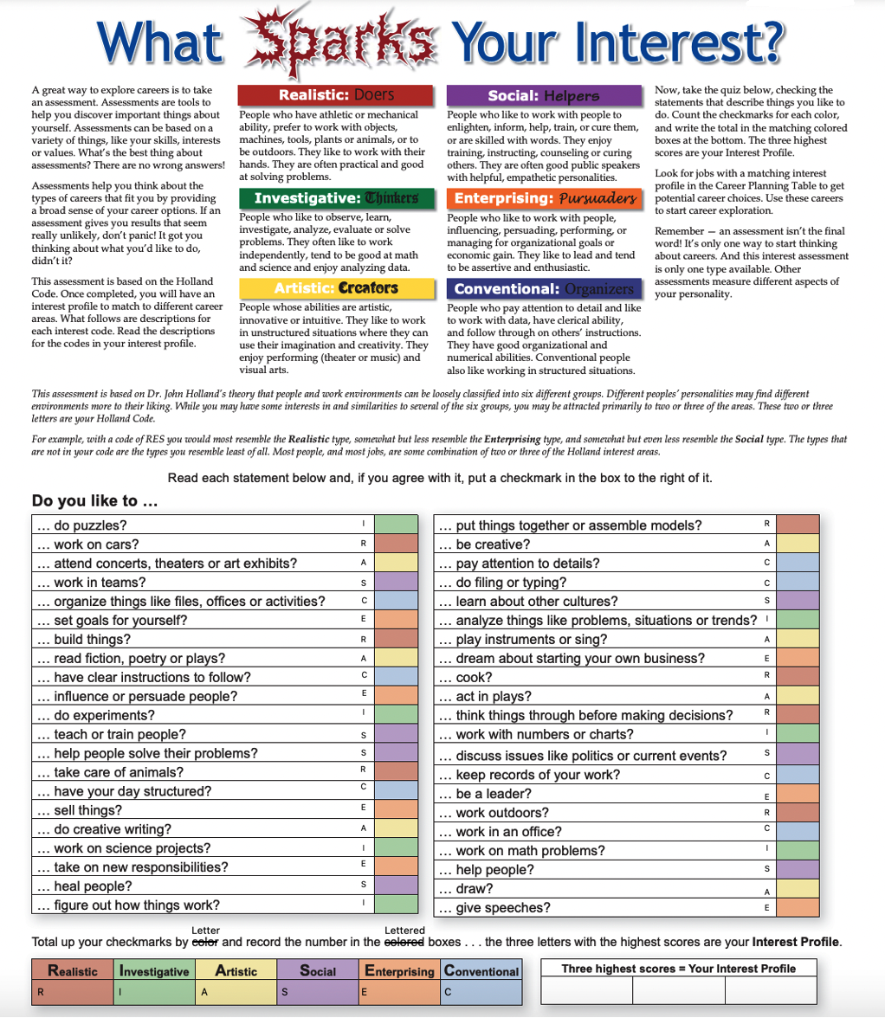

The 16 Career Clusters, Associated Holland Codes, and Troy Courses Relating to the Clusters

1. Agriculture, Food and Natural Resources (Realistic)
The agriculture, food and natural resources cluster includes everything related to the creation of agricultural products. This includes farmers, ranchers, scientists, engineers and veterinarians.
Some career pathways in Agriculture, Food and Natural Resources may require a bachelor’s degree in their specific field, while others train people through on-the-job experience.
The work environment is mostly outdoors, so most people who work in this field enjoy being outside.
Troy Courses: Math, Literature in the Land, Bio Ag Science, Environmental Ecology and Entomology, Earth Science, Chemistry, Intro to Business, Business Law, Accounting, All Ag Department classes, CAD, World of Food

2. Architecture and Construction (Realistic, Conventional)
The Architecture and Construction cluster includes people who are involved in designing, building and maintaining homes, industrial facilities, streets or bridges. The roles vary from carpenter helper to safety engineers, so educational requirements vary.
Most skilled tradespeople, like carpenters and plumbers, usually complete training directly on the job.
The people who work in this field have strong skills in math and are passionate about design, home improvement and decor. The typical work environment can be an office or the homes and businesses of your customers.
Troy Courses: Algebra II, Geometry, Business Calculations, Science in Society, Environmental Ecology and Entomology, Earth Science, Chemistry, Physics, Intro to Business, Business Law, Accounting, Drawing and Painting I & II, All Industrial Arts classes, *NTCC: Building Construction; Welding Technology; Mechanical Trades

3. Arts, Audio/Visual Technology, and Communications (Realistic, Artistic, Social, Enterprising)
The Arts, A/V Technology and Communications cluster may be the best career cluster for creative people. It includes journalists, actors, dancers, singers, radio announcers and behind-the-scenes workers.
Studying film and media arts or theater and drama could be beneficial if you’re interested in becoming an actor. Also, there are specialized certificate programs you could attend to become a sound engineer or a telecommunications technician.
The work environment can be a film, TV or recording studio or a theater. Most people who work in this cluster have an authentic passion for music, dance, cinema or fashion.
Troy Courses: Speech, Creative Writing, Mythology, Publishing and Presentation, Foreign Language (Spanish), All Art Department classes, All Music Department classes, Web Design, Concepts in Clothing

4. Business, Management, and Administration (Enterprising, Conventional)
The Business, Management and Administration cluster includes business analysts, accountants, HR professionals and managers, and many entry-level positions, like receptionists, secretaries and typists.
Most of the roles in Business, Management and Administration require a bachelor’s degree, and some accounting positions may also require the Certified Public Accountant license. The typical work environment is an office, and many roles require working directly with customers.
People who are interested in this career cluster usually have strong communication skills and business acumen.
Troy Courses: Business Calculations, Speech, College and Career Literacy, Publishing and Presentations, Foreign Language (Spanish), All Business Department classes, Honors Economics, Psychology

5. Education and Training (Artistic, Social)
The Education and Training career cluster includes teacher, tutor and instructor roles. This area also employs counselors, school psychologists and speech-language pathologists who offer support and guidance to students.
Elementary and secondary school teachers need both a bachelor’s degree and a license, while college teachers need an advanced degree. The typical work environment is a school or college.
This career cluster may be of interest for people who have strong leadership skills or want to act as role models for younger people. If you aspire to work in this field, it will be beneficial to have a passion for the subject you’ll teach.
Troy Courses: Mathematical Reasoning and Application (College Prep Math), Biology, Science in Society, Chemistry, Earth Science, Speech, Creative Writing, Writing about Philosophy, Novel and Drama, Mythology, Foreign Language (Spanish), All Art Department classes especially if Art Ed, Parenting and Family Life

6. Finance (Enterprising, Conventional)
The roles in the Finance cluster include auditor, financial analyst, treasurer, economist, bank worker, debt counselor or insurance professional. Many of the jobs in the Finance career cluster require a bachelor’s degree or specialized certifications. For example, getting a Certified Public Accountant or Certified Internal Auditor license may be helpful for certain roles.
The typical work environment is an office, an accounting studio or a tax collecting agency. The workers in this field usually have strong math skills and the ability to explain difficult concepts to customers who don’t work in the field.
Troy Courses: Statistics, Speech, Honors Economics, All Business Department classes, Financial Literacy

7. Government and Public Administration (Social, Enterprising)
The Government and Public Administration cluster includes people who help enforce the law. They’re tax collectors, municipal clerks, military workers and customs brokers. This cluster also includes postal service clerks, mail carriers and aircrew members.
A bachelor’s degree is a requirement for some positions and both judges and magistrates must have an advanced degree. Based on the career you want to pursue, you could also achieve a Municipal Clerks Certification, a Tax Assessor Certification or a Customs Broker License.
The work environment is typically a city’s municipal office or a customs office. A career in this cluster may be of interest for people who have great communication skills or an interest in politics.
Troy Courses: Algebra I & II, Statistics, Speech, Foreign Language (Spanish), Data Application: Excel/ Spreadsheet, Dynamic Presentation Applications, American History, US Civics and Government, World Cultures, Honors Economics, AP US Government and Politics, Psychology, Sociology

8. Health Science (Realistic, Investigative, Social, Conventional)
The Health Science cluster includes doctors, nurses, pharmacists, paramedics and healthcare operators. Specialized training is required for all the roles in Health Science. Nurses must attend nursing school and earn a license while doctors have more educational requirements, like earning a medical degree.
Emergency Medical Technicians must attend EMT training and get a national or state certification. Also, opticians must obtain a state license.
The work environment can be a hospital, private clinic, pharmacy retail chain or patients’ homes. People who are interested in this cluster usually have a natural predisposition to help others.
Troy Courses: Algebra I & II, Pre-calculus, Statistics, Calculus (if seeking Bachelor degree or professional degree), Anatomy & Physiology I, Anatomy and Physiology II, Chemistry, Genetics, Microbiology (if offered), Data Application: Excel/Spreadsheet, *NTCC: Health Assistant/Pre-Nursing

9. Hospitality and Tourism (Realistic, Artistic, Enterprising)
The Hospitality and Tourism cluster includes jobs you can do in restaurants, bars, tourist attractions, resorts, hotels and travel agencies.
Entry-level positions usually only require a high school diploma or equivalent. However, some higher roles like tourist guide or travel agent may require a bachelor’s degree and the knowledge of multiple languages The typical work environment can be the kitchen of a restaurant, a ticket office, a hotel reception or airport.
The career paths related to bars and restaurants may be of interest for people who love food and don’t mind working long hours standing. Career paths related to tourist attractions are suitable for well-educated people who have a passion for culture, arts and traveling.
Troy Courses: Speech, Intro to Business, Sales and Marketing, World Cultures, Foreign Language (Spanish), World of Food, *NTCC: Food Production and Management
10. Human Services (Artistic, Social)
The Human Services career cluster includes not only psychologists, social workers and child advocacy professionals but also paths like hairdresser, manicurist and cosmetologist.
The career pathways that relate to counseling and mental health require a minimum of a bachelor’s degree and a license. Those related to beauty and wellness require specialized training. For example, a person who wants to become a cosmetologist could attend a specific college course and then an apprenticeship at a beauty salon.
The work environment can be a hospital, a spa or a beauty salon. The workers in this cluster usually have strong interpersonal and listening skills and patience and empathy towards others.
Troy Courses: Speech, Foreign Language (Spanish), Parenting and Family Life, Psychology/Sociology, *NTCC: Cosmetology

11. Information Technology (Realistic, Investigative)
The Information Technology cluster is for aspiring developers, web designers, network administrators and computer support specialists. Other careers in this cluster are computer science teacher, computer forensic professional and information security analyst.
Degrees or industry certifications, like AWS Certified Developer or Microsoft Certified Solutions Expert, are very helpful when seeking many of these jobs. The people who work in this field usually require continuous training since technology evolves at a fast pace.
The work environment is typically an office. A career in Information Technology may be of interest for people who have a passion for the Internet, including assisting web navigation and fixing security issues.
Troy Courses: As many upper level Math courses as possible, As many Science classes as possible, Publishing and Presentation, Web Design, Data Applications, Excel/Spreadsheet, CAD, Technology and Society, Digital Art, *NTCC: Information Technology

12. Law, Public Safety, Corrections, and Security (Realistic, Investigative, Social, Enterprising)
Workers in the Law, Public Safety Corrections and Security cluster protect citizens. They’re police officers, security guards, attorneys, paralegals and FBI agents. Attorneys must earn a bachelor’s degree, complete three years of law school and then pass the final bar exam. A police officer must pass the Law Enforcement Entrance Exam and graduate from the Police Academy.
The work environment can be a jail, court, police station or public place where people need to be protected, such as pools, beaches and playgrounds.
Working in Law, Public Safety, Corrections, and Security may be of interest for people who are brave and have a strong desire to protect others.
Troy Courses: Chemistry, Statistics, Speech, Business Law, US Civics and Government, AP US Government and Politics, Health/Physical Education, Psychology/Sociology, Criminal Justice related courses (on-line courses)
13. Manufacturing (Realistic, Conventional)
The Manufacturing cluster can be great for people who enjoy working with their hands: equipment operators, millwrights, assemblers and warehouse workers. These roles usually only require on-the-job training, but there are other pathways that may require a bachelor’s degree. For example, there are workers who ensure safety in the factories, while others inspect the quality of products and services.
A typical work environment is an industrial unit. However, some workers can also work directly at their client’s home, to fix household appliances. A career in Manufacturing may be suitable for people who have strong manual skills and love DIY activities.
Troy Courses: Algebra I, II, Science and Society, Physics, College and Career Literacy, Foreign Language (Spanish), Energy, Power, and Transportation, Power and Machinery; Electronics, Materials and Processes; Welding, *NTCC: Machine Tool Technology, Welding, Mechanical Trades

14. Marketing, Sales and Service (Artistic, Social, Enterprising, Conventional)
The Marketing, Sales and Service cluster includes salespeople, telemarketers, real estate agents, customer service representatives, market research analysts and marketing managers.
A degree in Marketing, even if not required, can be beneficial. Also, people who want to work in online marketing should earn the Google Analytics Individual Qualification, the Google Ads Certification and the Facebook Blueprint Certification.
The work environment can be an office, a retail store or the home of the customer. A career in this field may interest those with excellent communication skills.
Troy Courses: Algebra I & II, Statistics, Speech, Publishing and Presentations, Honors Economics, All Business classes

15. Science, Technology, Engineering, and Mathematics (Realistic, Investigative)
This career cluster includes some of the most highly educated workers, like biologists, engineers, mathematicians, statisticians, chemists and geoscientists. All the roles require a minimum of a bachelor’s degree in an appropriate field and professional engineers must also earn a state license.
The work environment can be a laboratory, an industrial facility or a weather station. People who are interested in this career cluster are usually passionate about science, math or geography, and willing to continue training and education.
Troy Courses: As many Math courses and as many upper level Math courses as possible, Physics, As many upper level Science courses as possible, Speech, Publishing and Presentations, College and Career Literacy, CAD, Architecture, Engineering, Inventions and Innovations, Technology and Society, Electronics

16. Transportation, Distribution, and Logistics (Realistic, Conventional)
The Transportation, Distribution and Logistics cluster drive and fix vehicles or work behind the scenes to make sure that public transportation is efficient at all times. They are drivers, pilots, rail car repairers, parking lot attendants, civil engineers and transportation planners.
Pilots, train operators and truck drivers must be licensed, while engineering roles require an advanced degree. For rail car repairers, a specific certification is not required, but can be very helpful.
The work environment can be a car repair shop, a train, a bus or an office. The careers in this cluster may be attractive for people who have a passion for driving vehicles or fixing them.
Troy Courses: Business Calculations, Accounting, Environmental Ecology, Physics, College and Career Literacy, Foreign Language (Spanish), Energy, Power, Transportation; Power and Machinery; Electronics, *NTCC: Auto Mechanics Technology, Collision Repair Technology, Diesel Engine Technology

Suggested Course Sequences for Agriculture, Food and Natural Resources
Associated Holland Code(s) |  | Associated Career Cluster(s)
Realistic |  | Agriculture, Food, & Natural Resources
Sample Careers
Workforce (On the Job Training) |  |  |  | Technical/Skilled |  | Professional
Field Worker ● Maintenance Worker ● Harvester ● Fish and Wildlife Worker ● Animal Herder ● Ranch Hand ●Animal Caretaker ● Breeder ● Extension Service Worker ● Food Conservation Worker ● Wildlife Reserve Worker ● |  |  |  | ● Bio-Resource Technician ● Hydrology Technician ● Agri forester ● Fish and Wildlife Technician ● Ag & Field Technician ● Bio Technician ● Forest Conservationist ● GPS Technician ● Surveyor ● Veterinary Technician ● |  | ● Environmental Scientist ● Oceanographer ● Marine Biologist ● Agricultural Engineer ● Chemist ● Veterinarian ● Agronomist ● Geologist ● Marine Biologist ● Soil Conservationist ● Veterinarian ●
Recommended Course Progression
 | 9th |  | 10th |  | 11th |  | 12th
English | Keystone English 9  Honors Keystone English 9 |  | Keystone English 10  Honors Keystone English 10 |  | English 11  Honors English 11  College and Career Literacy  AP Language & Composition |  | English 12  Honors English 12  Literature in the Land  AP Literature & Composition
Math | Pre-Algebra |  | Keystone Algebra I Mod 1 |  | Keystone Algebra I Mod 2 |  | Geometry
 | Keystone Algebra I Mod 1 |  | Keystone Algebra I Mod 2 |  | Geometry |  | Accounting I, Business Calculations
 | Keystone Algebra 1 |  | Honors Geometry |  | Algebra II, Accounting I, Business Calculations, Other Math Elective(s)
 | Honors Geometry |  | Algebra II |  | Intro to Statistics, other higher level Math Elective, Accounting I, Business Calculations |  | Other Math Elective(s)
Science | Keystone Biology  Honors Keystone Biology |  | Earth Science, Science in Society, Physics, Chemistry, Honors Chemistry |  | Bio Ag Science, Environmental Ecology & Entomology, Other Science Electives |  | Science Elective(s)
Social Studies | American History III  Honors American History III |  | American History IV  Honors American History IV |  | World Cultures  Honors World Cultures |  | US Civics & Government  Honors US Civics & Government
Electives | SAE 1, Intro to Agricultural Education, Wildlife and Natural Resources Management |  | SAE 2, Forestry, Food Products and Processing, Intro to Business |  | SAE 3, Power and Machinery, Plant and Soil Studies, Business Law |  | SAE 4, Animal Studies, Biotechnology, Welding, Service Learning
Required | Physical Education  Career Exploration |  | Physical Education  Health |  | Physical Education  Financial Literacy |  | Physical Education  Activities for Life

Suggested Course Sequences for Arts, Communications, and Information Systems
Associated Holland Code(s) |  |  | Associated Career Cluster(s)
Realistic, Investigative, Artistic, Social, Enterprising (R, I, A, S, E) |  |  | Arts, Audio/Video Technology, & Communications (R, A, S, E)  Information Technology (R, I)
Sample Careers
Workforce (OJT) |  |  |  |  | Technical/Skilled |  | Professional
● Model ● Radio Operator ● Stagehand ● Stunt Performer ● Announcers ● Dancer ● Film Loader ● Photographer ● Floral Designer ● Florist ● Sound Technician ● TV, Video & Motion Picture ● Operator ● Desktop Publisher ● Circulation ● Copy Person ● Newsroom Worker ● Computer Operator ● |  |  |  |  | ● Actor ● Book Illustrator ● Choreographer ● Dancer ● Disc Jockey ● Musician ● Talent Agent ● Animator ● Artist ● Broadcast Technician ● Fashion Designer ● Jeweler ● Make-up Artist ● Recording Engineer ● Video Manager ● Computer Graphic Artist ● Web Designer ● Desktop Publisher ● Computer Support Specialist ● Software Engineer ● Computer Programmer ● Production Support Analyst ● |  | ● Art or Music Teacher ● Cinematographer ● Composer ● Film Editor ● Multi-Media Artist ● Music Critic ● Music Director ● News Broadcaster ● Producer & Director ● Editor ● Curator ● Advertising Creator ● Art Director ● Interior Designer ● Fashion Designer ● Industrial Designer ● Copy Writer ● News Writer ● Telecommunications ● Writer ● Computer Network Engineer ● E-Commerce Analyst ● Systems Software Engineer ● Systems Analyst ●
Recommended Course Progression
 |  | 9th |  | 10th |  | 11th |  | 12th
English |  | Keystone English 9  Honors Keystone English 9 |  | Keystone English 10  Honors Keystone English 10 |  | English 11  Honors English 11  College and Career Literacy  AP Language & Composition |  | English 12  Honors English 12  Literature in the Land  AP Literature & Composition
Math |  | Pre-Algebra |  | Keystone Algebra I Mod 1 |  | Keystone Algebra I Mod 2 |  | Geometry
 |  | Keystone Algebra I Mod 1 |  | Keystone Algebra I Mod 2 |  | Geometry |  | Math Elective(s)
 |  | Keystone Algebra 1 |  | Honors Geometry |  | Algebra II |  | Math Elective(s)
 |  | Honors Geometry |  | Algebra II |  | Math Elective(s) |  | Math Elective(s)
Science |  | Keystone Biology  Honors Keystone Biology |  | Earth Science, Science in Society, Physics, Chemistry, Honors Chemistry |  | Science Elective(s) |  | Science Elective(s)
Social Studies |  | American History III  Honors American History III |  | American History IV  Honors American History IV |  | World Cultures  Honors World Cultures |  | US Civics & Government  Honors US Civics & Government
Electives | Arts, Audio/Video Technology, & Communications | Creative Writing, Mythology, Composition I, Publishing & Presentations, Speech, Women in Literature, Spanish I, Spanish II, Ceramics I, Ceramics II, Ceramics III, Drawing & Painting I, Drawing & Painting II, Digital Art, Portfolio, Music Appreciation, Band, Choir, Music Theory, Intro to Theater Arts, Concepts in Clothing, Intro to Business, Business Law, Data Applications, Dynamic Presentation Applications, Sales & Marketing, Web Design, CAD I, Advanced CAD and Architecture, Engineering with CAD Applications, CAD IV, Materials & Processes I, Materials & Processes II, Construction, Welding, Service Learning, NTCC – Diversified Occupations (Seniors only)
 | Information Technology | Spanish I, Spanish II, Intro to Business, Business Law, Data Applications, Dynamic Presentation Applications, Sales & Marketing, Web Design, Accounting I, Business Calculations, Mathematical Reasoning & Application, Digital Art, CAD I, Advanced CAD and Architecture, Engineering with CAD Applications, CAD IV, Materials & Processes I, Electronics, Service Learning, NTCC – Information Technology
Required |  | Physical Education  Career Exploration |  | Physical Education  Health |  | Physical Education  Financial Literacy |  | Physical Education  Activities for Life

Suggested Course Sequences for Business, Management, and Administration
Associated Holland Code(s) |  | Associated Career Cluster(s) With Holland Codes
Realistic, Artistic, Social, Enterprising, Conventional (R, A, S, E, C) |  | Business, Management, & Administration (E, C)  Finance (E, C)  Hospitality & Tourism (R, A, E)  Marketing & Sales (A, S, E, C)
Sample Careers
Workforce (OJT) |  |  |  | Technical/Skilled |  | Professional
● Customer Service● Representative ● Shipping and Receiving Clerk ● Telemarketer ● Advertising Sales Agent ● Bank Teller ● Cashier ● Payroll Clerk ● Title Searcher ● Computer Operator ● Accounts Payable Office Manager ● Administrative Assistant ● Data Entry ● Retail Salesclerk ● School Secretary ● Account Executive ● |  |  |  | ● Computer Salesperson ● Graphic Designer ● Retail Tech ● Bank Collection Officer ● Claims Adjuster ● Legal Secretary ● Tax Preparer ● Paralegal ● Computer Support Specialist ● Software Engineer ● Computer Programmer ● Production Support Analyst ● Desktop Publisher ● Medical Secretary ● Real Estate Agent ● Restaurant Manager ● Sales Representative ● |  | ● Marketing Manager ● Certified Public Accountant ● Economist ● Financial Manager ● Securities Sales Representative ● E-Commerce Analyst ● Systems Software Engineer ● Systems Analyst ● Hospital Administrator ● Human Resources● Manager ● Chief Executive Officer ● Manufacturing Sales● Representative ● Business Analysts ● Project Manager ● Sports & Entertainment Agent●
Recommended Course Progression
 | 9th |  | 10th |  | 11th |  | 12th
English | Keystone English 9  Honors Keystone English 9 |  | Keystone English 10  Honors Keystone English 10 |  | English 11  Honors English 11  College and Career Literacy  AP Language & Composition |  | English 12  Honors English 12  Literature in the Land  AP Literature & Composition
Math | Pre-Algebra |  | Keystone Algebra I Mod 1 |  | Keystone Algebra I Mod 2 |  | Geometry
 | Keystone Algebra I Mod 1 |  | Keystone Algebra I Mod 2 |  | Geometry |  | Accounting I, Business Calculations
 | Keystone Algebra 1 |  | Honors Geometry |  | Algebra II, Accounting I, Business Calculations, Intro to Statistics, AP Statistics
 | Honors Geometry |  | Algebra II |  | Accounting I, Business Calculations, Intro to Statistics, AP Statistics, other higher level Math Elective
Science | Keystone Biology  Honors Keystone Biology |  | Earth Science, Science in Society, Physics, Chemistry, Honors Chemistry |  | Science Elective(s)
Social Studies | American History III  Honors American History III |  | American History IV  Honors American History IV |  | World Cultures  Honors World Cultures |  | US Civics & Government  Honors US Civics & Government
Electives | Composition I, Speech, Publishing & Presentations, Honors Economics, Sociology, Psychology, Sports History, Intro to Business, Data Applications, Dynamic Presentation Applications, Sales & Marketing, Business Law, Web Design, Spanish I through IV, Drawing & Painting I & II, Digital Art, Concepts in Clothing, World of Food, Service Learning, Electronics, Inventions & Innovations, Manufacturing Processes, Food Products & Processing, NTCC – Food Production & Management, Diversified Occupations (Seniors Only)
Required | Physical Education  Career Exploration |  | Physical Education  Health |  | Physical Education  Financial Literacy |  | Physical Education  Activities for Life

Suggested Course Sequences for Engineering, Manufacturing, and Technology (STEM)
Associated Holland Code(s) |  | Associated Career Cluster(s)
Realistic, Investigative, Conventional (R, I, C) |  | Architecture & Construction (R, C)  Manufacturing (R, C)  Science, Technology, Engineering, & Mathematics (R, I)  Transportation, Distribution, & Logistics (R, C)
Sample Careers
Workforce (OJT/Apprenticeships) |  | Technical/Skilled |  | Professional
● Carpet Installer ● Drywall Worker ● Roofer ● Machine Operator ● Industrial Machine Mechanic ● Baggage Handler ● Dockworker ● Freight Handler ● Laborer ● Warehouse Worker ● Brick Mason ● Carpenter ● Electrician ● HVAC ● Plumber ● Machinist ● Surveyor ● |  | ● Grader & Dozer Operator ● Electric Technician ● Metal Engineering Technician ● Supervisor ● Welder ● Civil Engineering Technician ● Robotics Technician ● CAD/CAM Technician ● Laser Technicians ● Auto Mechanic ● Air Traffic Controller ● Auto Body Repair ● Bus Driver ● Diesel Mechanic ● Dispatch ● Motorcycle Mechanic ● Taxi Driver ● Truck Driver ● Truck Terminal Manager ● |  | ● Construction Manager ● Cost Estimators ● Industrial Production Manager ● Purchasing Agent ● Astronaut ● Nuclear Engineer ● Petroleum Engineer ● NASA Scientist ● Chemical Engineer ● Technical Writer ● Architect ● Civil Engineering ● Industrial Engineer ● Mechanical Engineering ●
Recommended Course Progression
 | 9th | 10th | 11th |  | 12th
English | Keystone English 9  Honors Keystone English 9 | Keystone English 10  Honors Keystone English 10 | English 11  Honors English 11  College and Career Literacy  AP Language & Composition |  | English 12  Honors English 12  Literature in the Land  AP Literature & Composition
Math | Pre-Algebra | Keystone Algebra I Mod 1 | Keystone Algebra I Mod 2 |  | Geometry
 | Keystone Algebra I Mod 1 | Keystone Algebra I Mod 2 | Geometry |  | Accounting I, Business Calculations
 | Keystone Algebra 1 | Honors Geometry | Algebra II, Accounting I, Business Calculations |  | Mathematical Reasoning & Application, Pre-Calculus, Intro to Statistics
 | Honors Geometry | Algebra II | Mathematical Reasoning & Application, Pre-Calculus, Intro to Statistics |  | Calculus, AP Calculus, AP Statistics
Science | Keystone Biology | Earth Science, Science in Society, Chemistry | Bio Ag Science, Environmental Ecology & Entomology |  | Other Science Elective(s)
 | Honors Keystone Biology | Physics, Honors Chemistry | Physics II, Chemistry II |  | Physics III, AP Chemistry
Social Studies | American History III  Honors American History III | American History IV  Honors American History IV | World Cultures  Honors World Cultures |  | US Civics & Government  Honors US Civics & Government
Electives | Speech, Composition I, Spanish I-IV, Drawing & Painting, CAD I-IV, Materials & Processing I & II, Electronics, Inventions & Innovations, Manufacturing Processes, Construction, Energy, Power & Transportation, Welding, Service Learning, NTCC – Building Construction, Mechanical Trades, Automotive Mechanics Technology, Collision Repair Technology, Diesel Mechanics Technology, Machine Tool Technology, Welding Technology, Diversified Occupations (Seniors Only)
Required | Physical Education  Career Exploration | Physical Education  Health | Physical Education  Financial Literacy |  | Physical Education  Activities for Life

Suggested Course Sequences for Health Science Technology
Associated Holland Code(s) |  | Associated Career Cluster(s)
Realistic, Investigative, Social, Conventional (R, I, S, C) |  | Health Science (R, I, S, C)
Sample Careers
Workforce (OJT) |  |  |  | Technical/Skilled |  | Professional
● Hospital Worker ● Patient Care Technician ● Dialysis Technician ● EEG Technician ● Home Health Aide ● Nurses Aide, Orderlies ● Pharmacy Technicians ● Physical Therapy Aide ● Animal Caretaker ● Breeder ● Extension Service Worker ● Food Conservation Worker ● Wildlife Reserve Worker ● Hazardous Waste Technician ● Optician ● Data Entry ● Surgical & Mapping Technicians ● |  |  |  | ● Certified Nursing Assistant ● Dental Hygienist ● Emergency Medical Tech. ● Licensed Practical Nurse ● *Medical Lab Technician ● Personal Trainer ● Radiological Technician ● Respiratory Therapist ● Dental Lab Technician ● Fish & Game Worker ● Forest Conversationalist ● GPS Technician ● Surveyor ● Veterinary Technician ● Nano Technician ● Sound Engineer ● *Biological Technicians ● Chemical Technicians ● |  | ● Athletic Trainer ● Speech/Language Pathologist ● Dietician ● Physician Assistant ● Medical Examiner ● Pharmacist ● Physician ● Physical Therapist ● Registered Nurse ● Agronomist ● Geologist ● Marine Biologist ● Soil Conservationist ● Veterinarian ● Chemist ● Environmental Scientist ● Geneticist ● Statistician ● Zoologist ● Nuclear Engineer ●
Recommended Course Progression
 | 9th |  | 10th |  | 11th |  | 12th
English | Keystone English 9  Honors Keystone English 9 |  | Keystone English 10  Honors Keystone English 10 |  | English 11  Honors English 11  College and Career Literacy  AP Language & Composition |  | English 12  Honors English 12  Literature in the Land  AP Literature & Composition
Math | Pre-Algebra |  | Keystone Algebra I Mod 1 |  | Keystone Algebra I Mod 2 |  | Geometry
 | Keystone Algebra I Mod 1 |  | Keystone Algebra I Mod 2 |  | Geometry |  | Accounting I, Business Calculations
 | Keystone Algebra 1 |  | Honors Geometry |  | Algebra II |  | Mathematical Reasoning & Application, Pre-Calculus, Intro to Statistics
 | Honors Geometry |  | Algebra II |  | Mathematical Reasoning & Application, Pre-Calculus, Intro to Statistics |  | Calculus, AP Calculus, AP Statistics
Science | Keystone Biology |  | Chemistry |  | Environmental Ecology & Entomology, Bio Ag Science |  | Science Elective(s)
 | Honors Keystone Biology |  | Honors Chemistry |  | Physics, Chemistry II, Anatomy & Physiology I & II |  | Genetics, Microbiology, Physics II, AP Chemistry
Social Studies | American History III  Honors American History III |  | American History IV  Honors American History IV |  | World Cultures  Honors World Cultures |  | US Civics & Government  Honors US Civics & Government
Electives | Speech, Composition I, Spanish I-IV, Psychology, Sociology, Parenting & Family Life, Service Learning, Animal Studies, Service Learning, NTCC – Health Assistant/Pre-Nursing, Diversified Occupations (Seniors Only)
Required | Physical Education  Career Exploration |  | Physical Education  Health |  | Physical Education  Financial Literacy |  | Physical Education  Activities for Life

Suggested Course Sequences for Human Services
Associated Holland Code(s) |  | Associated Career Cluster(s)
Realistic, Investigative, Artistic, Social, Enterprising (R, I, A, S, E) |  | Education & Training (A, S)  Human Services (A, S)  Government & Public Administration (S, E)  Law, Public Safety, and Security (R, I, S, E)
Sample Careers
Workforce (OJT) |  |  |  | Technical/Skilled |  | Professional
● Child Care Worker ● Cosmetics Representative ● Dry Cleaning Operator ● Home Health Aide ● Home Care Aide ● Library Assistant ● Teacher’s Assistant ● Armed Services Career ● Bailiff ● Postal Services Worker ● Security Guard ● Utility Worker ● Aerobics Instructor ● Travel Agent ● Waitress ● Baker ● |  |  |  | ● Barber ● Cosmetologist ● Fashion Designer ● Manicurist ● Massage Therapist ● Mortician ● Truck Driver ● Personal Trainer ● Teacher’s Aide ● Armed Services Career ● Crime Lab Technician ● Fire Fighter ● Postmaster ● Bartender ● Chauffeur ● Flight Attendant ● Meat Cutter ● Chef ● |  | ● Funeral Director ● Marriage & Family Therapist ● Mental Health Counselor ● School Counselor ● College Professor ● Principal ● Teacher ● City Manager ● Criminologist ● FBI Agent ● Lawyer ● Probation/Parole Officer ● Park Ranger ● Workforce Director ● Athletic Agent ● Executive Chef ● Family Planner ● Food Services Manager ● Hotel/Motel Management ●
Recommended Course Progression
 | 9th |  | 10th |  | 11th |  | 12th
English | Keystone English 9  Honors Keystone English 9 |  | Keystone English 10  Honors Keystone English 10 |  | English 11  Honors English 11  College and Career Literacy  AP Language & Composition |  | English 12  Honors English 12  Literature in the Land  AP Literature & Composition
Math | Pre-Algebra |  | Keystone Algebra I Mod 1 |  | Keystone Algebra I Mod 2 |  | Geometry
 | Keystone Algebra I Mod 1 |  | Keystone Algebra I Mod 2 |  | Geometry |  | Accounting I, Business Calculations
 | Keystone Algebra 1 |  | Honors Geometry |  | Algebra II |  | Mathematical Reasoning & Application, Pre-Calculus, Intro to Statistics
 | Honors Geometry |  | Algebra II |  | Mathematical Reasoning & Application, Pre-Calculus, Intro to Statistics |  | Calculus, AP Calculus, AP Statistics
Science | Keystone Biology  Honors Keystone Biology |  | Earth Science, Science in Society, Physics, Chemistry, Honors Chemistry |  | Science Elective(s)
Social Studies | American History III  Honors American History III |  | American History IV  Honors American History IV |  | World Cultures  Honors World Cultures |  | US Civics & Government  Honors US Civics & Government
Electives | Speech, Composition I, Women in Literature, Mythology, Psychology, Sociology, World War II, Sports History, Intro to Business, Data Applications, Dynamic Presentation Applications, Sales & Marketing, Business Law, Web Design, Spanish I-IV, Parenting & Family Life, World of Food, Concepts in Clothing, Service Learning, NTCC – Cosmetology, Food Production & Management, Health Assistant/Pre-Nursing, Teacher Academy/Early Childhood Education, Diversified Occupations (Seniors Only)
Required | Physical Education  Career Exploration |  | Physical Education  Health |  | Physical Education  Financial Literacy |  | Physical Education  Activities for Life

COURSE DESCRIPTIONS

*Classes are weighted by 1.03
**Classes are weighted by 1.05
^NCAA Approved Core Classes

*For placement in Honors level and AP courses, it is strongly recommended that a student have earned an 87% or higher in the prior core subject (i.e. 87% in English 9 or Honors English 9 to be placed in Honors English 10)

ENGLISH DEPARTMENT

KEYSTONE ENGLISH 9^
PREREQUISITE-NONE GRADE 9
CREDIT-1.0 #300
This course is a survey of literature examining multiple literary genres including short stories, poetry, novel, drama and non-fiction. This course is focused on the continued development of the foundational skills needed to advance into the Keystone Literature course. Analysis of literary elements and devices are the focus of formal writing. This course also emphasizes the integration of textual evidence within student writing. Formal writing skills are practiced through the completion of the writing of multiple constructed response paragraphs, literary analysis papers and a formal research paper. The Keystone Exam will be given at the conclusion of this course.

HONORS KEYSTONE ENGLISH 9*^
PREREQUISITE-NONE GRADE 9
CREDIT 1.0 #350
In preparation for the Keystone Exam, this course is a survey of literature examining multiple literary genres including short stories, poetry, novel, drama and non-fiction. Analysis of literary elements and devices are the focus of reading and formal writing. This course also emphasizes the integration of textual evidence within student writing. Formal writing skills are practiced through writing multiple constructed response paragraphs, literary analysis papers, and a formal research paper. The Keystone Exam will be given at the conclusion of this course.

KEYSTONE ENGLISH 10^
PREREQUISITE-ENGLISH 9 GRADE 10
CREDIT 1.0 #301
In preparation for the Keystone Exam, this course is a survey of literature examining multiple literary genres including short stories, poetry, novel, drama and non-fiction. Analysis of literary elements and devices are the focus of reading and formal writing. This course also emphasizes the integration of textual evidence within student writing. Formal writing skills are practiced through writing multiple constructed response paragraphs, literary analysis papers and formal research paper.

HONORS KEYSTONE ENGLISH 10*^
PREREQUISITE-ENGLISH 9 GRADE 10
CREDIT 1.0 #351
In tenth grade, students study both ancient and contemporary literature from around the world. The focus of the course is to examine the common themes found throughout world literature (fiction and non-fiction) regardless of the culture that produced them. The course units are organized around these universal themes. Each unit allows for close study of literary works, as well as consideration of historical and cultural context. Students come to grasp the relationship between local concerns and universal questions. Throughout the year, students will conduct background research, analyze literature, participate in class discussions, study vocabulary, learn about the writing process and write essays. In addition to shorter writing pieces, students will be mastering the “constructed response” paragraph, the “ten percent summary,” and the literary analysis paper.

ENGLISH 11^
PREREQUISITE-ENGLISH 9,10 GRADE 11
CREDIT 1.0 #302
Concentration is on American literature, speech, expository writing, and vocabulary. It will consist of an intensive survey of America’s literature with the intention of enhancing the student’s sense of cultural literacy. The organization, structure, research and delivery of an informative speech will be emphasized. Expository writing will be stressed with the prime intention of enhancing the development of logical and analytical thinking. Vocabulary development will concentrate on broadening the student’s reading recognition vocabulary.

HONORS ENGLISH 11*^
PREREQUISITE-ENGLISH 9,10 GRADE 11
CREDIT 1.0 #352
Concentration is on American Literature, speech, expository writing, and vocabulary. It will consist of an intensive survey of the development and progress of American Literature. Emphasis is on the major themes, which have occupied the writers of that literature. The organization, structure, research and delivery of the persuasive speech will also be stressed. Writing will deal with the structure of the expository essay, the use of concrete examples to effectively support opinions, and a study of the stylistic techniques, which would facilitate competency in that particular mode of expression. A concentrated study of vocabulary will also be emphasized.

ENGLISH 12^
PREREQUISITE-ENGLISH 9,10,11 GRADE 12
CREDIT 1.0 #303
Focus will be on the literary backgrounds of British Literature from the days of the Anglo-Saxons to the 17th Century. Basic to the course is a study of the various literary genres. Considerable stress will be placed on development of communication skills in written form. Emphasis is placed on the student’s written analysis of the works studied through class discussion of works read and tests, quizzes, thematic essays. and book reflections. The course also includes developmental skills in grammar and vocabulary and required research.

HONORS ENGLISH 12*^
PREREQUISITE-ENGLISH 9,10,11 GRADE 12
CREDIT 1.0 #353
Focus will be on the literary backgrounds of British Literature from the days of the Anglo-Saxons to the 17th Century and will provide students with a comprehensive background for the study of contemporary literature. Emphasis is placed on the student’s written analysis of the works studied through class discussion of works read and tests, quizzes, thematic essays, and book reflections. Critical thinking, listening and research skills are incorporated. Vocabulary development is pursued through the context of the works in progress along with the needed literary terms and concepts for the study of literature. A research paper is required. (Possible Dual Enrollment Credit)

LITERATURE IN THE LAND^
PREREQUISITE-ENGLISH 9,10,11/CCL GRADE 12
CREDIT 1.0 #375
Literature and the Land is a literature and writing course first; second, it is a study of environmental and agricultural literacy. Through the lens of literature, we will study humans’ changing relationship to the land, with a focus on forests, from the past to the present. The course explores the history of people's relationship with nature from mythological times to the present, sequencing from nature journaling, to myths, to contemporary environmental nonfiction, to studies of environmental themes in fiction and poetry, and ending with the action research project. Students will practice essay writing, analysis writing, argumentative writing, public speaking, and research writing.

AP ENGLISH – LITERATURE AND COMPOSITION**^
PREREQUISITE-ENGLISH 9,10,11, Teacher Recommendation GRADE 12
CREDIT 1.0 #395
This course prepares students to write for academic discourse. The course teaches students to think critically, write in a variety of genres for various audiences, analyze language, and evaluate the craft of writing both stylistically and rhetorically. An AP exam must be taken in May for the purpose of exempting from a college course at the student’s expense. Students may earn up to 6 college credits. (Possible Dual Enrollment Credit)

COMPOSITION I^
PREREQUISITE - NONE GRADES 9,10,11,12
CREDIT 1.0 #365
This is for students to establish a sound writing foundation. Students write for different purposes and audiences with a specific focus on informative/explanatory and argumentative texts. Students must organize ideas, concepts, and information to make important connections. The writing process is practiced including multiple drafts of essays while students work to develop tone and style. This course does not replace English but is meant to refine skills needed to improve written communication for high school courses.

AP ENGLISH – LANGUAGE AND COMPOSITION**^
PREREQUISITE – ENGLISH 9,10, Teacher Recommendation GRADES 11,12
CREDIT 1.0 #396
The AP English Language and Composition course aligns to an introductory college- level rhetoric and writing curriculum, which requires students to develop evidence-based analytic and argumentative essays that proceed through several stages or drafts. Students evaluate, synthesize, and cite research to support their arguments. Throughout the course, students develop a personal style by making appropriate grammatical choices. Additionally, students read and analyze the rhetorical elements and their effects in non-fiction texts, including graphic images as forms of text, from many disciplines and historical places.

COLLEGE AND CAREER LITERACY
PREREQUISITE-ENGLISH 9,10 GRADES 11,12
CREDIT 0.5 #397
This course will allow students to have the opportunity to select a career or career-mission to demonstrate their understanding of the ELA and College and Career Readiness standards addressed in the course. Through the use of BIE PBL Gold standard diagram, students will sequence through the design steps of: Challenging Problem or Question, Sustained Inquire, Authenticity, Student Voice & Choice, Reflection, Critique & Revision and Public Product. The course will culminate with a website designed to showcase the learning and a potential on-site visitation component with a professional opportunity beyond the classroom. An underlying component of the visitation component is a professional opportunity beyond the classroom. An underlying component of the course will be the design of a student blog responding to self-selected texts from a course list of suggest readings.

CREATIVE WRITING^
PREREQUISITE-NONE GRADES 9,10,11,12
CREDIT 0.5 #361
In this writing workshop course, students will develop creative writing skills by developing short stories, poetry, one-act plays, etc. Emphasis will be on the writing process, as well as the written product. Students who wish to become involved in a writing project will find this course useful and instructive.

MYTHOLOGY^
PREREQUISITE-NONE GRADES 9,10,11,12
CREDIT 0.5 #390
This course is designed for both the general and the academic student. The course will offer reading in World Mythologies but will focus on the Mythologies of Greece and Rome.

SPEECH*^
PREREQUISITE-NONE GRADE 11,12
CREDIT 0.5 #363
Speech is designed to improve students’ speaking and listening skills through a study of basic formal and informal speech situations. It will, therefore, consist of a study of the communication process and its importance for success in all occupations. Speech games stressing that process will be used to give students a unique awareness of the various elements involved in speaking and listening and will also be used to overcome students’ initial inhibitions typical of first speaking-listening encounters. Effective characteristics and techniques for the preparation and delivery of any type of speech will be studied. Instruction, research, preparation, delivery, and evaluation of impromptu speeches, informative speeches, demonstration speeches, and persuasive speeches will be a major focus of the course. (Possible Dual Enrollment Credit)

WOMEN IN LITERATURE
PREREQUISITE- NONE GRADES 11,12
CREDIT 0.5 #370
The focus in this quarter course will be a thematic study of female roles in literature. The course is not limited by time period, nor is it constrained by genre. We will read literature by and about fascinating women, from Emily Dickinson to Maya Angelou to Laurie Halse Anderson. Their power of words will be analyzed, as will their literary, cultural and social context. The magnitude of change in women’s lives during the last two centuries will determine the range of subjects that we will investigate: coming of age, the feminist and leader, the wife, the mother, and the spiral into mental illness.

SOCIAL STUDIES DEPARTMENT
*For placement in Honors level courses, it is strongly recommended that a student have earned an 87% or higher in the prior core subject (i.e. 87% in American History III or Honors American History III to be placed in Honors American History IV)

AMERICAN HISTORY III-PROGRESSIVE ERA^
PREREQUISITE-NONE GRADE 9
CREDIT 1.0 #501
This course covers the period 1860 to 1930 chronologically. Assignments will be made from the text as well as supplements from other historical texts and documents. In addition several books will be read to gain insight into a particular period of U.S. History, including, All Quiet on the Western Front, and Freedom Road. Grades are determined by tests, quizzes, reports and in-class performance, including current events.

HONORS AMERICAN HISTORY III-PROGRESSIVE ERA*^
PREREQUISITE-TEACHER RECOMMENDATION GRADE 9
CREDIT 1.0 #503
Curriculum design will be similar to that of American History III (#501). Students will be expected to work at a more accelerated pace. Topics will be covered in more detail and students will be expected to analyze information on a more abstract level of thinking. This course has an emphasis on writing and will require a final project for class presentation. The final project is equivalent to the final exam.

AMERICAN HISTORY IV-MODERN ERA^
PREREQUISITE-AMERICAN HISTORY III GRADE 10
CREDIT 1.0 #502
This course will cover the period from 1932 to the present chronologically. Assignments will be made from the textbooks as well as from various current articles. In addition, at least one of the following books will be read to gain insight into a particular period of U.S. History. These are: Grapes of Wrath, Hiroshima, Night, and Black Like Me. Grades will be determined by tests, quizzes, reports, class presentations, in-class performance, and a final exam that demonstrates the student’s understanding of this particular period in American History.

HONORS AMERICAN HISTORY IV-MODERN ERA*^
PREREQUISTE-HONORS AMERICAN HISTORY III GRADE 10
CREDIT 1.0 #504
Curriculum design will be similar to that of American History IV. Students will be expected to work at a more accelerated pace. Topics will be covered in more detail and students will be expected to analyze information on a more abstract level of thinking. This course has an emphasis on reading historical novels, doing several writing projects and will require a final project for class presentation, as well as a final exam.

WORLD CULTURES^
PREREQUISITE-NONE GRADE 11
CREDIT 1.0 #521
The purpose of this course is to study different areas of the world and focus upon historical and present-day culture and geography, family life and structure, social organizations, attitude on education, religious beliefs and institutions, economic life, political trends, and the intellectual and artistic accomplishments of men and women within the culture. The course will cover the Middle East, Africa, China (East Asia), Latin America and Canada. The study of each of the cultures will be supplemented by the development of reading, writing, research, geography, critical thinking, technological use and presentation skills. Upon completion of this course, students shall be able to: Have a working understanding of various political, economic, social and religious institutions; understand the five themes of geography and their impact on political, economic, social and cultural organizations; analyze social consequences of environmental, economic, political and cultural events.

HONORS WORLD CULTURES*^
PREREQUISITE- HONORS AMERICAN HISTORY GRADE 11
CREDIT 1.0 #522
The purpose of this course is to analyze and discuss different areas of the world and focus upon historical and present-day culture and geography, family life and structure, social organizations, attitude on education, religious beliefs and institutions, economic life, political trends and the intellectual and artistic accomplishments of men and women within the culture. The course will cover the Middle East, Africa, China (Far East), Latin America and Canada. The study of each of the cultures will be supplemented by the development of reading, writing, research, geography, critical analysis, technological use and presentation skills. Upon completion of this course, students will have an understanding of the common elements of culture and appreciation of cultural diversity; understanding of political principles and systems to encourage competent civic participation in the democratic society; understanding of the impact of science and technology on individuals and societies; reflective attitudes toward personal values, the values of others and the cultural values evident in students’ own and other societies; understanding and appreciation of the interdependence of peoples and nations in a global society; understanding of how human beings view themselves and others, individually and in groups.

US CIVICS & GOVERNMENT^
PREREQUISITE-NONE GRADE 12
CREDIT 1.0 #540
This course investigates the organization of American government and includes an overview of the historical significance and provisions of the Constitution; the Bill of Rights; Congress; the Supreme Court; the Presidency; political parties and interest groups. The objective of the course is to lay the proper foundation for informed citizenship and participation in the political process through debate, class presentations and in-depth classroom discussion.

HONORS US CIVICS & GOVERNMENT*^
PREREQUISITE- HONORS AMERICAN HISTORY III, IV GRADE 12
CREDIT 1.0 #541
This course introduces students to the theory and practice of American government. Students will learn about the formation of governments as a solution to collective action problems, the history and evolution of American political processes, institutions, and public policies from the founding period to the present, including the importance of federalism, culture, public opinion, parties, interest groups, elections and the media, the nature and quality of American democracy, political challenges, dilemmas, and reform. There will be frequent use of interactive classroom technologies, multimedia presentations, and political debates to encourage independent thinking, critical analysis, and lively discussions. Active class participation and discussion is required. (If you have not previously had two honor social studies classes, you must have an A average in two previous social studies classes and a teacher recommendation.)

PSYCHOLOGY^
PREREQUISITE: NONE GRADES 11,12
CREDIT 1.0 #561
Psychology introduces students to several traditional psychological concepts from a number of contemporary perspectives such as biological, psychosocial, and cognitive. It starts with an introduction to psychology as well as background information on research methods. Students will learn about foundational ideas and theories as they analyze human growth and development, the various aspects of learning and intelligence, personality, and behavior. Students will explore the nature of being human and learn to identify various disorders as well as discuss risk factors and treatments for each one. Students will also delve into the science of human interactions by exploring topics such as socialization, individual interactions, and group behaviors.

HONORS PSYCHOLOGY*^
PREREQUISITE: NONE GRADES 11,12
CREDIT 1.0 #563
This course is an introduction to the science of human behavior and mental processes. Students examine the relationship between the nervous system and behavior, learning, perception, language, personality, intelligence, and psychopathology. It is intended to be a survey of the history, the major questions, and the concepts within the discipline plus the methods, the contemporary theories and the applications of psychology in everyday life. The course is a prerequisite for upper-level courses in psychology and will be of particular interest to those students majoring in social sciences, human services, nursing, health technologies, education, and consumer-oriented career fields. In addition to filling many Penn College program requirements, the course successfully transfers to other colleges and universities. (Dual Enrollment Credit)

SOCIOLOGY^
PREREQUISITE-NONE GRADES 11,12
CREDIT 1.0 #526
Introduction to the theories, principles, concepts, and major research in sociology. Study includes society’s impact on human behavior and consciousness as well as the ways in which individuals and groups affect cultures and their social structures. A comparison of different cultures and subcultures provides an understanding of the relativity and universality of social values, norms, and beliefs. Sociology is a discipline dealing with various aspects of human social life, groups and societies as well as global society. Its subject matter is our own behavior as social beings as well as our connections with larger society in which we are born, and with the world at large. The scope of sociology is extremely broad, ranging from the analysis of passing encounters between individuals in the street up to the investigations of global social processes. Sociological approach will facilitate student’s understanding of the foundation around which their lives and society itself is organized. It will help students develop a habit of critical sociological thinking which will empower them as well as help them in making informed choices in life and not be driven blindly by social forces.

HONORS SOCIOLOGY*^
PREREQUISITE-NONE GRADES 11,12
CREDIT 1.0 #527
This course is an introduction to basic sociological concepts and major contemporary sociological theories. Specific attention is given to the social impact of culture, socialization patterns, deviance, and social forces relating to stratification based upon socio-economic status, sex/gender, race/ethnicity, and education. Students will demonstrate the skills necessary to construct a social impact statement. Identify biases that influence thinking about sociological issues. Explain the core concepts and sociological theories. Articulate the respective arguments about the appropriate social policies that are advocated to alleviate or solve social problems. Develop basic research skills in the gathering of data about social problems. Upon completion student should be able to demonstrate the skills necessary to construct a social impact statement, identify biases that influence thinking about sociological issues, explain the core concepts and sociological theory, articulate the respective arguments about the appropriate social policies that are advocated to alleviate or solve social problems and develop basic research skills in the gathering of data about social problems. (Dual Enrollment Credit)

WORLD WAR II ^
PREREQUISITE-AMERICAN HISTORY IV GRADES 10,11,12
CREDIT 0.5 #511
This course will cover the causes, events during, and effects of World War II with a focus on military objectives in the European and Pacific theaters and the Holocaust. Assignments will include quizzes, written responses, mapwork, film review, and a final project for presentation.

SPORTS HISTORY
PREREQUISITE-NONE GRADES 9,10,11,12
CREDIT 0.5 #513
This course will cover the development of sports in America, with a focus upon indigenous people, women, desegregation, and sporting events that have aligned with major historical events. Assignments will be made using various books, historical texts, and other documents. Assignments will include quizzes, written responses, literary analysis, film review, and a final presentation.

MATHEMATICS DEPARTMENT

PRE-ALGEBRA
PREREQUISITE-NONE GRADE 9
CREDIT 1.0 #860
This course may be scheduled for students who completed the Integrated Math 8 program in grade 8. This course will further develop the skills learned in Math 8 and extend these skills to prepare them to enter the Module 1 Keystone Algebra I curriculum. Students should take Keystone Algebra I Module 1 the year after they take this class.

KEYSTONE ALGEBRA I MODULE 1^
PREREQUISITE-NONE GRADES 9, 10
CREDIT 1.0 #867
This course will be scheduled for students who completed the Integrated Math 8 program in grade 8 or the Pre-Algebra curriculum in grade 9. This course will further develop the skills learned in Math 8 or Pre-Algebra and extend these skills through the Module 1 Keystone Algebra I curriculum. Students must take Keystone Algebra I Module 2 the year after they take this class.

KEYSTONE ALGEBRA I MODULE 2^
PREREQUISITE-NONE GRADES 10, 11
CREDIT 1.0 #868
This course will be scheduled for students who completed Keystone Algebra I Module 1. This course will further develop the skills learned in Module 1 and extend these skills through the Module 2 Keystone Algebra I curriculum. Students will take the Algebra I Keystone Exam at the end of this course.

KEYSTONE ALGEBRA I^
PREREQUISITE-NONE GRADES 9, 10
CREDIT 1.0 #861
This course will be scheduled for those students who have not scored proficient on their Keystone Algebra 1 exam or enter the district without Algebra I credit. The topics in Algebra to be studied are: writing and solving equations, linear algebra, linear inequalities, exponent and radical properties, systems of equations and inequalities, polynomials, probability, and data. The topics learned are applied to real world problems to develop higher level thinking skills. The students will take the Algebra I Keystone Exam at the end of this course.
GEOMETRY^
PREREQUISITE-ALGEBRA I GRADES 10,11,12
CREDIT 1.0 #870
This is a course of basic geometry in which students will deepen their understanding of two and three dimensional objects and their properties. The study of geometry develops logical thinking and problem solving skills. Topics which are covered include 1) points, lines, angles, and planes 2) polygons with emphasis on quadrilaterals, triangles and right triangles 3) circles and 4) basic introduction to trigonometry. Geometry is a required math course for graduation. Students must successfully complete Algebra I to take Geometry. This course is not geared for those students intending to continue with the study of higher-level math classes.

HONORS GEOMETRY*^
PREREQUISITE-ALGEBRA I GRADES 9,10,11,12
CREDIT 1.0 #871
This course is for students intending to continue their study of higher-level mathematics. It will cover the same material as outlined in the geometry course, but at a more rapid rate and more in-depth. Additional material to be presented would include coordinate geometry and the writing of two-column deductive proofs.

ALGEBRA II^
PREREQUISITE-ALGEBRA I, GEOMETRY GRADES 9,10,11,12
CREDIT 1.0 #862
Algebra II is a sequential course that follows Algebra I and Geometry and is designed for those students intending to continue with the study of higher-level math courses. Any student who intends to go to college to study a math or science related field needs to take Algebra II. The course builds upon the basic concepts of Algebra I, and then expands to include a careful study of the complex number system, non-linear expressions and equations, patterns, applications of functions and relations, and graphing.

MATHEMATICAL REASONING AND APPLICATIONS*^
PREREQUISITE-ALGEBRA II GRADES 11,12
CREDIT 1.0 #841
This course is designed to cover the Pennsylvania standards including mathematical reasoning, numbers and operations, algebra, measurement, data analysis and probability. It is a course that should prove valuable to the student who is planning to attend college in a non-mathematical field. Students who have taken Calculus or received an 80% or higher in Pre-Calculus CANNOT take this course. (Possible Dual Enrollment Credit)

PRE-CALCULUS*^
PREREQUISITE-ALGEBRA I, II, HONORS GEOMETRY GRADES 10,11,12
CREDIT 1.0 #880
Academic college-bound student should take this course, unless they are going into a field which is totally unrelated to math and science. The course begins with an in-depth review of concepts from Algebra II, then a detailed study of trigonometric functions with applications, trig graphs, and trig identities. Also included in this course is the study of conic sections and sequences and series.

INTRO TO STATISTICS & PROBABILITY*^
PREREQUISITE-HONORS GEOMETRY, ALGEBRA II GRADES 10,11,12
CREDIT 1.0 #884
This is a basic course in statistics and probability that is suitable for a variety of students. All four of the major components of statistics will be studied. They include the collection, analysis, interpretation, and presentation of data. The course will culminate with examination of the methods of statistical inference. The course is appropriate for any student who plans to enter such fields as economics, business, education, psychology, sociology, biology, engineering or medicine. Successful completion of this course should prove to be adequate preparation for the usual college courses offered in the above fields.

AP STATISTICS**^
PREREQUISITE-INTRO TO STATISTICS GRADES 11,12
CREDIT 1.0 #887
This course includes the study of all four major statistical concepts: collecting, analyzing, interpreting and presenting data. The methods of inferential statistics will be emphasized. The outline of content is dictated by the AP curriculum, and it will be altered when necessary. At this time, the AP exam requires the use of a TI-83 calculator so the content of this course will be facilitated accordingly. An AP exam, at the student’s expense, must be taken in May for the purpose of exempting from a college course. (Possible Dual Enrollment)

CALCULUS*^
PREREQUISITE-PRE-CALCULUS GRADES 10,11,12
CREDIT 1.0 #885
Every student who plans to attend college with a concentration in mathematics, science, or a related field should take Calculus I. The course consists of the study of functions, limits, differentiation and integration. Derivatives and their applications to maximum, minimum, and inflection points are studied in detail. All of these are applied to problems that exist in the real world. For example, derivatives will be used to calculate velocity, acceleration, and position.

AP CALCULUS AB**^
PREREQUISITE-CALCULUS GRADES 11,12
CREDIT 1.0 #886
This course presents Calculus from the graphical, numerical and symbolic points of view. The course includes a review of derivatives and their applications. A detailed study of integrals and their applications will be presented. This course is specifically designed for placement of a student into a college curriculum. An AP exam, at the student’s expense, must be taken in May for the purpose of exempting from a college course. (Possible Dual Enrollment)

BUSINESS CALCULATIONS
PREREQUISITES-ALGEBRA I, GEOMETRY GRADES 11,12
CREDIT 1.0 #810
This course is for the student electing business in a community college, business school, or the world of work. In this course students will learn how math is used in common business problems as well as every day, personal situations. Students will study both math and important vocabulary that is commonly used in business today. This course is counted as a math credit toward graduation.

ACCOUNTING I
PREREQUISITE-ALGEBRA I, GEOMETRY GRADES 11,12
CREDIT 1.0 #211
Accounting I develops an understanding of the accounting cycle from the recording of opening entries, to the preparation of financial statements. Students will develop a sense of accuracy, neatness, and regular attendance. Many of the principles and practices of accounting are of value in the daily lives of everyone. This may be used as a Math credit if a student has passed Algebra I and Geometry.

SCIENCE DEPARTMENT

KEYSTONE BIOLOGY^
PREREQUISITE-NONE GRADE 9
CREDIT 2.0 #950/#956
This course requires field work and class participation. Ecosystems, populations, succession, interactions among organisms and natural cycles are topics that will be explored. Laboratory assignments and projects may be conducted throughout the course. (Life Science)

HONORS KEYSTONE BIOLOGY*^
PREREQUISITE-NONE GRADE 9
CREDIT 2.0 #951/#955
This course is to prepare students for the Keystone Biology Exam and prepare students that plan on pursuing a career in a STEM related field. The topics explored in this course are basic biological principal, chemical basis for life , biogenetics, homeostasis and transport , cell growth and reproduction, genetics, theory of evolution, and ecology. Numerous laboratory exercises will enhance the understanding of these biological concepts and how they apply to everyday life. (Life Science)

SCIENCE IN SOCIETY^
PREREQUISITE-NONE GRADES 10,11,12
CREDIT 1.0 #900
This course is for students who need to have a credit in physical science. This is a course in applied science that relates the technology of our society to the scientific principles that underlie it. Concepts of force, work, rate, resistance, energy and power will form the core of this course. Each unit builds on the earlier ones and blends the accumulated knowledge into a continuous entity. (Physical Science) *This is a low-level physics course. If you have already passed Physics I, you cannot register for this course.

EARTH SCIENCE^
PREREQUISITE-NONE GRADES 10,11,12
CREDIT 1.0 #952
This course deals with eh makeup of the earth as well as the forces and processes that have and are shaping it. The study of rocks and minerals are stressed as a basis for the other areas of concentration. These areas will include glaciation, volcanism, oceanography, geomorphology, and paleontology. Emphasis will be placed on the processes and structures of the above as related to man. Time is also spent on soils, their formation, structure, use and conservation. (Physical Science)

CHEMISTRY^
PREREQUISITE-ALGEBRA I GRADES 10,11,12
CREDIT 1.0 #920
This science-technology-society course studies the make-up and behavior of the major resource areas of water, metals and petroleum in terms of their use, both ecologically and geopolitically, in real time. The labs for this course involve everyday items and practical applications. This could include students planning on college in a non-science-oriented field or general education majors. It does not qualify for the Chemistry II prerequisite. (Physical Science) This course should not be taken if you have taken Honors Chemistry.

HONORS CHEMISTRY*^
PREREQUISITE-ALGEBRA (80% RECOMMENDED) GRADES 10,11,12
CREDIT 1.0 #921
This course is geared to students who consistently maintain an “A” or “B” average in their science and math courses. Also, any student entering into science, math, nursing, medical fields, or college-level agriculture courses should seriously consider this course. There will be numerous laboratory exercises to be performed with written reports for each one. These lab reports will be used to enhance understanding of chemical concepts. For further information, contact your science teacher. (Physical Science) This course should not be taken if you have taken General Chemistry.

CHEMISTRY II*^
PREREQUISITE-HONORS CHEMISTRY, HONORS BIOLOGY GRADES 11,12
CREDIT 1.0 #944
Chemistry II is designed to be a semester course, which will confirm, expand and deepen the student’s knowledge of chemistry. It is our intention that each student will be able to successfully master a college chemistry course after completing this course. The course is written in behavioral terms so that the method of instruction may vary from large group instruction to individual instruction. (Physical Science) Algebra II is highly recommended.

AP CHEMISTRY **^
PREREQUISITE-HONORS CHEMISTRY I, CHEMISTRY II, ALGEBRA II GRADES 11,12
CREDIT 1.0 #943
The AP chemistry course is designed to be the equivalent of the general chemistry course usually taken during the first college year. This course differs from Chemistry II, in that it emphasizes chemical calculations, mathematical formulation of chemical principles, and extensive laboratory work. An AP exam, at the student’s expense, must be taken in May for the purpose of exempting from a college course. Students can earn up to 6 college credits at participating institutions. (Physical Science) (Possible Dual Enrollment Credit)

PHYSICS I^
PREREQUISITE-ALGEBRA I, GEOMETRY GRADES 10,11,12
CREDIT 1.0 #970
Physics is the study of physical processes in nature, focusing on changes in systems and how physical concepts (variables) are related to cause these changes. These systems can range from the very small (atomic phenomena) to the very large (celestial bodies) and many things in between. The first semester course covers vector mathematics, kinematics (motion), static and dynamic forces, work and energy, linear momentum and impulse, circular motion, static and dynamic torques, angular momentum and simple and complex machines. Concepts will be presented through lecture, demonstration and lab practicum, with assessments for each. (Physical Science)

PHYSICS II*^
PREREQUISITE-PHYSICS I GRADES 11,12
CREDIT 1.0 #971
Physics is the study of physical processes in nature, focusing on changes in systems and how physical concepts (variables) are related to cause these changes. These systems can range from the very small (atomic phenomena) to the very large (celestial bodies) and many things in between. The second semester course covers fluid mechanics, gas laws, thermodynamics, wave mechanics, sound, electromagnetic radiation, properties of EM radiation, optics, electricity (static and DC circuitry), electromagnetism (including AC circuitry), nuclear physics and modern physics. Concepts will be presented through lecture, demonstration and lab practicum, with assessments for each. (Physical Science) (Possible Dual Enrollment Credit)

PHYSICS III**^
PREREQUISITE-PHYSICS I, PHYSICS II GRADE 12
CREDIT 1.0 #975

Physics is the study of physical processes in nature, focusing on changes in systems and how physical concepts(variables) are related to cause these changes. These systems can range from the very small (atomic phenomena) to the very large (celestial bodies) and many things in between. The third semester course is designed to fill in any topics missed in Physics I or II and prepare students for the AP Physics I and Physics II tests. Concepts will be presented through lecture, demonstration and lab practicum, with assessments for each. (Physical Science)

ANATOMY & PHYSIOLOGY I *^
PREREQUISITE – HONORS BIOLOGY (80%), HONORS CHEMISTRY I (80%) GRADES 11,12
CREDIT 1.0 #940
It is the intent of this course to build an understanding and working knowledge of the structural and functional levels of the body, cellular physiology and anatomy, cellular metabolism, tissues, and the integument system. This course is designed for the science-oriented student who plans to enter college and major in one of the science-oriented occupations that require a strong background in sciences such as nursing, medical assistants, laboratory technologists, physician’s assistants, dental hygienists, physical therapists, EMT, etc. There will be numerous laboratory exercises to be performed that are correlated to the material being studied. (Life Science) (Possible Dual Enrollment Credit)

ANATOMY & PHYSIOLOGY II*^
PREREQUISITE-ANATOMY & PHYSIOLOGY I GRADES 11,12
CREDIT 1.0 #945
It is the intent of this course to provide an understanding of the skeletal system, the muscular system, the nervous system and how the body maintains itself on a day-to-day basis through the mechanisms of circulation, respiration, digestion, urinary functions and buffer systems. Anatomy and physiology of the reproductive systems and the development of a human will also be studied. This anatomy and physiology course is designed for the science-oriented student going into an occupation that requires a strong background in sciences such as nursing, medical assistants, laboratory technologists, physician’s assistants, dental hygienists, physical therapists, EMT, etc. There will be numerous laboratory exercises to be performed that are correlated to the material being studied. (Life Science) (Possible Dual Enrollment Credit)

GENETICS*^
PREREQUISITE-HONORS BIOLOGY, HONORS CHEMISTRY GRADES 11,12
CREDIT 1.0 #947
Genetics is a field that has exploded over the last decade. This course is designed to introduce students to the foundations of genetics and the basic principles of heredity. Emphasis will be placed on chemistry of DNA, replication, transcription and translation. (Life Science)

MICROBIOLOGY*^
PREREQUISITE-HONORS BIOLOGY, HONORS CHEMISTRY GRADES 11,12
CREDIT 1.0 #946
This is a course designed to introduce students to the basic concepts of microbiology and the spread of disease. Students will learn the structure and function of microscopic organisms. Adaptations of microorganisms will be discussed, as well as the current epidemic of resistant bacteria. Emphasis will be placed on laboratory work and students will be expected to master aseptic transfers and techniques. (Life Science)

FORENSICS – THE SCIENCE OF CRIME SOLVING
PREREQUISITE-BIOLOGY GRADES 10,11,12
CREDIT 0.5 #974

Forensic science is the study and application of science to the process of law and involves the collection, examination, evaluation and interpretation of evidence. This course will examine different parts of forensics (i.e. serology, toxicology, ballistics, pathology, criminal profiling, forensic psychology, and more) and see how forensics has played a part in real cases that have happened throughout history. Students will have an opportunity to learn about different career paths that could be taken in forensics.

ENVIRONMENTAL ECOLOGY AND ENTOMOLOGY (E3)
This is a series of 4 quarter-credit courses allowing students interested in pursuing a career in the ecology, environmental or entomology fields a practical, hands-on opportunity to work on site and in the lab deepening their knowledge. Students will have a first-hand look at what it is like to collect, analyze, present and determine long term implications of specific interaction in ecological settings. Informed consent must be turned in before starting the course. (Life Science)

E3: DISEASE CAUSING ARTHROPODS
PREREQUISITE- BIOLOGY GRADES 10,11,12
CREDIT 0.25 #929

This course will only be offered in Quarter 1 each year. This course is one of four environmentally based classes that is designed for students interested in pursuing a career in the fields of ecology, environmental, and/or entomology with an emphasis on hands-on field and lab experiences to deepen their knowledge. Students will have a first-hand look at what it is like to collect, analyze, present, and determine long term implications of specific interactions in ecological settings, for example varying plot studies and tick study. Informed consent must be turned in before starting the course. (Life Science) Proficiency on the Biology Keystone Exam is strongly recommended prior to taking the course.

E3: ENVIRONMENTAL HEALTH
PREREQUISITE- BIOLOGY GRADES 10,11,12
CREDIT 0.25 #934
This course may be offered in Quarter 2 and/or 3 each year. This course is one of four environmentally based classes that is designed for students interested in pursuing a career in the fields of ecology, environmental, and/or entomology with an emphasis on hands-on field and lab experiences to deepen their knowledge. Students will have a first-hand look at what it is like to collect, analyze, present, and determine long term implications of specific interactions in ecological settings, for example bee study and the use of microscopes. Informed consent must be turned in before starting the course. (Life Science) Proficiency on the Biology Keystone Exam is strongly recommended prior to taking the course.

E3: METAMORPHOSIS & DISSECTIONS
PREREQUISITE- BIOLOGY GRADES 10,11,12
CREDIT 0.25 #935
This course may be offered in Quarter 2 and/or 3 each year. This course is one of four environmentally based classes that is designed for students interested in pursuing a career in the fields of ecology, environmental, and/or entomology with an emphasis on hands-on field and lab experiences to deepen their knowledge. Students will have a first-hand look at what it is like to collect, analyze, present, and determine long term implications of specific interactions in ecological settings, for example grasshopper study and frog study . (Life Science) Proficiency on the Biology Keystone Exam is strongly recommended prior to taking the course.

E3: STREAM STUDY
PREREQUISITE- BIOLOGY GRADES 10,11,12
CREDIT 0.25 #936
This course will only be offered in Quarter 4 each year. This course is one of four environmentally based classes that is designed for students interested in pursuing a career in the fields of ecology, environmental, and/or entomology with an emphasis on hands-on field and lab experiences to deepen their knowledge. Students will have a first-hand look at what it is like to collect, analyze, present, and determine long term implications of specific interactions in ecological settings, for example varying plot studies, macroinvertebrate study, and mosquito study. Informed consent must be turned in before starting the course. (Life Science) Proficiency on the Biology Keystone Exam is strongly recommended prior to taking the course.

BUSINESS DEPARTMENT

INTRODUCTION TO BUSINESS
PREREQUISITE-NONE GRADES 9,10,11,12
CREDIT 1.0 #203
This course will introduce the student to the world of business and help prepare them for the economic roles of consumer, worker and citizen. This course will also serve as a background for other business courses they may take in high school and in college. It will also assist them with consumer decision making, prepare students for future employment, and help them effectively perform responsibly as a citizen. Starting Your Own Business, Famous Entrepreneur projects and a checkbook simulation are some of the projects presented in this class.

DATA APPLICATIONS: EXCEL/SPREADSHEET
PREREQUISITE – NONE GRADES 9,10,11,12
CREDIT 0.5 #227
In this nine-week elective course, students will develop skills in spreadsheet and database software applications. Using Microsoft Excel, students will have the opportunity to learn how to use software to create basic spreadsheets, use formulas and functions, and design graphs. Using Microsoft Access, students will learn the basics of designing a database for mailing contact lists and inventory lists. The emphasis of this course is on efficient and accurate production of documents.

DYNAMIC PRESENTATION APPLICATIONS
PREREQUISITE – NONE GRADES 9,10,11,12
CREDIT 0.5 #229
In this nine-week elective course, students will develop skills in electronic presentation applications. Using Microsoft PowerPoint, Prezi.com, Google Presentations, Picasa and other presentation-assisted software applications, students will learn how to design, animate, illustrate, and produce sophisticated electronic business, class, research, statistical and graphic presentations for large and small audiences. Emphasis in this class will be on quality and accurate student-produced electronic presentations.

SALES & MARKETING
PREREQUISITE-INTRO TO BUSINESS GRADES 10,11,12
CREDIT 0.5 #235
In this semester course, students will be instructed on the marketing cycle—involving product planning, research, development, pricing, distribution, advertising, and selling. Students will gain basic marketing principles and practices at the retail level. In addition, students will learn how to market a product using desktop publishing and presentation software. Projects will be presented to the entire class.

ACCOUNTING I
PREREQUISITE-Algebra I, Geometry GRADES 11,12
CREDIT 1.0 #211
Accounting is used in both personal finances and the operation of a business. This course is designed to provide students with an introduction of the principles, practices and procedures of accounting. The accounting procedures presented will prepare students to manage their personal finances and gain accounting skills for both employment and college. All students, regardless of their career choice, can benefit from accounting instruction since it is an integral part of everyday life. This may be used as a Math credit if a student has passed Algebra I and Geometry.
ACCOUNTING II
PREREQUISITE-Accounting I GRADE 12
CREDIT 1.0 #212
The advanced course in accounting continues with the principles and practices learned in Accounting I. Ownership forms such as sole-proprietorship, partnership, and corporation are explored. This class also emphasizes a departmentalized merchandising business and manufacturing business. College-bound students, regardless of their major, can benefit from accounting instruction since numerous majors such as Management, Marketing and Finance requires knowledge of Accounting. (Possible Dual Enrollment Credit)

BUSINESS LAW^
PREREQUISITE-NONE GRADES 10,11,12
CREDIT 1.0 #250
This course maintains a fundamental emphasis on business law, while introducing personal law topics that interest students. Students will be given the opportunity to learn about contracts, ethics, employment law, credit, banking, partnerships, bankruptcy, and more. This is a must have class for students’ personal lives and those who wish to pursue a business-related college degree.

WEB DESIGN
PREREQUISITE –NONE GRADES 11,12
CREDIT – 1.0 #894
This is a one-semester course in which students will develop IT skills in web design and production, using Macromedia Studio MX web tools. This is a project-based, tutorial course, requiring student independence, responsibility, and maturity. The key skills stressed will be design, communication, and project management. (This course is an introductory coverage of the Internet and online Web Technologies. Skills learned include how to plan, create and maintain static Web pages) (Possible Dual Enrollment Credit)

LANGUAGE DEPARTMENT

SPANISH I^
PREREQUISITE-NONE GRADES 9,10,11,12
CREDIT 1.0 #421
Spanish I deals with intensive drills in pronunciation, oral comprehension and speaking the Spanish language. The course is to help students develop linguistic proficiency and cultural appreciation. Material will be in audio, video, and printed formats. Each student hopefully will attain an acceptable degree of proficiency in the four skills of listening, speaking, reading and writing within a minimum period of time. Total classroom participation is expected. * An 80% in prior year’s English is recommended.
SPANISH II^
PREREQUISITE-SPANISH I, TEACHER’S PERMISSION REQUIRED GRADES 10,11,12
CREDIT 1.0 #422
This will be a continuation of the Spanish I course procedures and methods. It will involve a more comprehensive study of the Spanish language with a great emphasis on understanding grammar, especially verbs. Spanish II involves a deeper study of the Spanish culture along with strong emphasis on speaking and listening comprehension. Total classroom participation is expected.

SPANISH III*^
PREREQUISITE-SPANISH I, II, TEACHER’S PERMISSION REQUIRED GRADES 11,12
CREDIT 1.0 #423
This course will involve the more complex structure of basic Spanish and expands the cultural themes of the introductory and Spanish II courses. Students at this level should acquire a command of the key vocabulary and structures necessary for personal communication as well as an appreciation of the Spanish-speaking world. More independent reading, grammar review, and further practice in oral communication and speaking will be expected.

SPANISH IV*^
PREREQUISITE-SPANISH I, II, III, TEACHER’S SIGNATURE REQUIRED GRADE 12
CREDIT 1.0 #424
Spanish IV is an honors course that stresses vocabulary acquisition; grammar study; development of more advanced reading skills and gives the student an introduction to Spanish and Latin American art and literature. Conversation in Spanish is expected for the majority of the course.

ART DEPARTMENT

CERAMICS I
PREREQUISITE-NONE GRADES 9,10,11,12
CREDIT 0.5 #141
This course offers the student an introduction to hand built pottery. Most of the course is devoted to the hand building techniques such as coil, pinch and slab. The remainder of the time will be spent glazing the projects. A fee is required for the purchase of materials. Fees are set at the beginning of each school year.

CERAMICS II
PREREQUISITE-CERAMICS I GRADES 9,10,11,12
CREDIT 0.5 #142
This course offers further exploration in clay on an advanced level. A fee is required for the purchase of materials. Fees are set at the beginning of each school year. A 90% in Ceramics I is recommended

CERAMICS III
PREREQUISITE-CERAMICS I & II, APPROVAL FROM INSTRUCTOR GRADES 10,11,12
CREDIT 0.5 #137
This course will be utilizing ceramics techniques from Ceramics I and II to create projects that students will be designing themselves with the help of the instructor. Students will be creating their own rubrics for projects and will determine the objectives of the projects they design. The end result will be a cohesive portfolio of ceramic work. It is recommended that students obtained a 90% or above in both Ceramics I and II. A fee is required for the purchase of materials. Fees are set at the beginning of each school year.

DRAWING AND PAINTING I
PREREQUISITE-NONE GRADES 9,10,11,12
CREDIT 0.5 #122
This course includes primarily pencil drawing and improving basic drawing skills, specifically in a realistic style. If time allows, watercolor painting will be introduced.

DRAWING AND PAINTING II
PREREQUISITE-DRAWING AND PAINTING I GRADES 9,10,11,12
CREDIT 0.5 #124
This course will build on the fundamentals of drawing from Drawing and Painting I. Students will have the opportunity to advance their drawing skills while experiencing basic techniques in both watercolor and acrylic paint. Drawing and Painting I is a pre-requisite for this course. A 90% in Drawing and Painting I is recommended.

DIGITAL ART
PREREQUISITE-NONE GRADES 9,10,11,12
CREDIT 0.5 #131
This class will explore the process of creating works of art which are technology-dependent. The primary focus will be on photo-manipulation using Adobe Photoshop. Students will have the opportunity to utilize digital cameras and incorporate their own photographic images into their artwork. Throughout the course, students will be required to complete a variety of assignments ranging from self-portraits to surrealistic compositions.

PORTFOLIO
PREREQUISITE- APPROVAL FROM INSTRUCTOR GRADES 11,12
CREDIT 0.5 #125
This course will explore the requirements for submitting a portfolio in an art-related major at the college level. Students will have the opportunity to build their portfolio as well as determine what art-related majors are available and what careers those degrees could lead to. This course is intended for 11/12 grade. Students should consult with the teacher prior requesting the course.

FAMILY AND CONSUMER SCIENCE

PARENTING AND FAMILY LIFE
PREREQUISITE-NONE GRADES 9,10,11,12
CREDIT 0.5 #602
This course will help you develop skills and attitudes needed as a parent and caregiver. It is also appropriate for anyone interested in careers that involve working with children, such as pediatrician, day care worker, foster parent, teacher or child psychologist. Topics covered include understanding family structure, formation, and function; pregnancy and birth; and the physical, mental, social and emotional development of children. If arrangements can be made, on-site observation and participation with children takes place at local day care and/or preschool facility.

THE WORLD OF FOOD
PREREQUISITE-NONE GRADES 10,11,12
CREDIT 0.5 #611
This beginner’s cooking class includes instruction on and application of basic cooking skills to assure proper interpretation of a recipe, proper use of kitchen equipment, accurate measuring techniques, and safety rules. This class also includes building an understanding of making nutritional food choices, understanding the principles of baking, and a study of United States regional foods and foods from other countries. A fee is required for the purchase of materials. Fees are set at the beginning of each school year.
CONCEPTS IN CLOTHING
PREREQUISITE-NONE GRADES 9,10,11,12
CREDIT 0.5 #612
Learn methods of creating garments for careers in fashion merchandising, advertising, fabric care service, or just for fun. A beginning sewer can learn basic sewing skills while the experienced sewer can enhance their skills. In addition to sewing skills, learn about fabric care, expand your creative world and learn to select color, lines and fabrics best suited for your body shape. The teacher purchases all materials needed. A fee is required for the purchase of materials. Fees are set at the beginning of each school year.

MUSIC DEPARTMENT

MUSIC APPRECIATION
PREREQUISITE-NONE GRADES 9,10,11,12
CREDIT 0.5 #11
This is one marking period course taking a cross-curricular approach to the appreciation and experience of all types of music, the different ways music appeals to people, and how music is present in our everyday lives. Students will experience how all subjects, including History, Literature, Visual Art, Mathematics, Science and Language are all present in music through a series of class, group, and individual projects and discussions. Students will create and perform music using composition techniques and instruments such as bucket drums, keyboards and guitars. Students will also have a unique opportunity to experience music through daily listening activities by responding and connecting to music and how it appeals to them.

CONCERT BAND
PREREQUISITE-INSTRUCTION ON A MUSICAL INSTRUMENT GRADES 9,10,11,12
CREDIT 1.0 #10
Students who play any standard band instrument are welcome to participate. The main purpose of band is to prepare students to advance their technical and musical skills on their instrument with a large ensemble through a wide variety of literature, with opportunities for individual performances. Pull-out lessons are required; students must attend a given number for full credit each quarter. Both ensemble and solo literature will be studied in this setting. Attendance at 2-3 concerts is expected each year, with additional performance opportunities for smaller ensembles. Students will have the opportunity to apply/audition for County Band, District Band and Jazz Band. Students are highly encouraged to participate in the Trojan Marching Band on either an instrument or in the band front (guard/majorettes) but participation is not required. Enrollment in Concert Band is required for instrumentalists’ participation in Marching Band (unless a student is in Vo-Tech). Participation in this group requires commitment to all local parades and football games, as well as additional in-school activities as requested. Participation in the August Band Camp is REQUIRED for membership in the Trojan Marching Band.

CONCERT CHOIR
PREREQUISITE-NONE GRADES 9,10,11,12
CREDIT 1.0 #20
Concert Choir is a non-auditioned ensemble designed to teach students how to sing. Within the context of a group, students will learn proper mechanics and music literacy skills that will prepare them for a lifetime of good singing. The Concert Choir sings music of all time periods as well as styles that range from Renaissance to Gospel to Pop. Choir performs 2-3 public performances per school year and attendance is expected. Members are also eligible to audition for a number of extra-curricular ensembles including: County and District Chorus as well as the Chamber Choir.

MODERN BAND
PREREQUISITE: None GRADES: 9, 10, 11, 12
CREDIT 0.5
Modern Band is a new school based music program that utilizes popular music as its central canon. Modern Band teaches students to perform the music they know and love, and to compose and improvise. Styles that are studied include rock, pop, reggae, hip-hop, rhythm & blues, electronic dance music, and other contemporary styles as they emerge. Modern Band also utilizes (but is not limited to) the musical instruments that are common to these genres: guitar, bass, drums, piano, voice, and technology.

MUSIC THEORY
PREREQUISITE: MUST BE ABLE TO READ PITCHED AND RHYTHMIC MUSICAL NOTATION. SIGNATURE REQUIRED FROM MS. ERDMANN TO TAKE THIS COURSE. GRADES 10,11,12
CREDIT 0.5 #15/16
This course covers basic music theory as well as basic music writing, aural skills, harmonic analysis and composition. Students will gain a deeper understanding of the mechanics of written music and how it functions and be able to identify those mechanics in relation to their previous musical study. Course will be paced with some regard to student progress. This course will cover approximately the same material that would be taught in a first-semester Music Theory course in a collegiate music program and is strongly recommended for any student wishing to pursue a career in music, the performing arts or participation in post-graduate musical activities.

Introduction to Theater Arts
PREREQUISITE-NONE GRADES 9,10,11,12
CREDITS 0.5 #18
This course is an exploration of the various arts that make up the creation of a complete theater production: theater literature, scriptwriting, directing, acting, set design, lighting, make-up, costuming, and marketing. This is NOT an auditioned course and all students will be expected to be actively involved in all aspects of theater production. This will be a hands-on course and students will be asked to prepare material for class presentation and critique, attend a formal theater performance, and apply learned skills to assist with the production of the Drama Club’s spring musical.

PHYSICAL EDUCATION AND HEALTH DEPARTMENT

PHYSICAL EDUCATION
PREREQUISITE-NONE GRADES 9,10,11,12
CREDIT 0.25 #71
Units of participation are designed to offer a wide range of activities form team sports, lifetime sports, outdoor adventure, team building, and fitness concepts. The goal of Physical Education at Troy High School is to create physically literate individuals that are knowledgeable, confident, and skilled enough to participate in regular physical activities long after high school days. Regular participation in a wide range of physical activities promotes a lifelong healthy lifestyle. Units of participation will be infused with career and health standards as they pertain to the physical education setting. All units provided in the curriculum are linked to both the Pennsylvania state Standards as well as the National association for Sport and Physical Education (NASPE).
HEALTH
PREREQUISITE-NONE GRADE 10
CREDIT 0.25 #80
This course is designed to increase student awareness and knowledge as to proper physical and mental health especially in relation to the individual. Topics include a study of the body’s structure and needs, mental health and mental illness, family living, communicable diseases, and subjects of interests to students including the use and abuse of drugs, alcohol, and nicotine and sexual development. GRADUATION REQUIREMENT

STRENGTH TRAINING AND CONDITIONING
PREREQUISITE-NONE GRADES 9,10,11,12
CREDIT 0.5 #76
Strength training and conditioning is a lifetime activity that all students can do. The goal of this course is to introduce/reinforce weightlifting and to allow students to create their own personalized workout plan. The purpose of this course is to allow all students regardless of athletic ability to use the school weight room and to enhance their overall well-being. Students will be required to keep track of their weight, lifting schedule/reps, and nutrition intake throughout the marking period.

YOGA AND MEDITATION
PREREQUISITE-NONE GRADES 9,10,11,12
CREDIT 0.25 #74
This course will introduce students to beginner and intermediate yoga. Students will learn various poses to increase muscular flexibility and strength. The practice of meditation will teach students various breathing techniques as well as mental hygiene which encourages students to improve their focus, mental health and emotional stability.

SURVIVAL
PREREQUISITE-NONE GRADES 9,10,11,12
CREDIT 0.5 #88
This course is offered in the Spring semester only. This course will test students mentally and physically. Students will learn how to tie knots, read a map, track animals, build traps, set up camp, predict weather, identify poisonous and edible plants, prepare food and provide first aid. Students will also be challenged physically by participating in the team-building courses, rope bridging, and first aid carries. This class will consist of quizzes, journal entries, essays and a mandatory final exam that will be a three day trip in May (Fri, Sat, & Sun). Students that sign up for this class should have self-discipline, be prepared to participate in all activities, accept constructive criticism and accept challenges willingly.

ACTIVITIES FOR LIFE
PREREQUISITE-NONE GRADE 12
CREDIT 0.25 #73
This class aims to provide 12th grade students with an opportunity to incorporate physical activity and life-long leisure experiences into their lifestyle though game play, practice, and community exposure. The goal of 12th grade Activities for Life class is to create physically literate individuals that are knowledgeable, confident, and skilled enough to participate in regular physical activities long after their high school days. Regular participation in a wide range of physical activities promotes a lifelong healthy lifestyle. CPR and first aid certification will be included in the Activities for Life class. Other units of participation will be infused with opportunities to become lifelong participants and enthusiasts. All units provided in the curriculum are linked to both the Pennsylvania State Standards as well as the National Association for Sport and Physical Education (NASPE). GRADUATION REQUIREMENT

ADAPTED PE/OLYMPIC TRAINING
PREREQUISITE-INSTRUCTOR RECOMMENDATION GRADES 9,10,11,12
CREDIT 1.00 #S77
This course is a unified sports course. It is designed to prepare students to compete in various contests such as bocce ball, bowling, swimming and track & field. Class time will be spent learning the skills for each of the events and practicing them. Peer helpers will be used to assist students and to help with recording practice scores/times.

FUTURE READY/OTHER

DRIVER EDUCATION
PREREQUISITE-NONE GRADE 10
CREDIT 0.25 #90
The classroom phase of Driver Education is recommended for all 10th grade students.

CAREER EXPLORATION
PREREQUISITE-NONE GRADE 9
CREDIT 0.5 #609
This required course covers Students will be given the chance to explore career opportunities and learn strategies for career choice and preparation. GRADUATION REQUIREMENT

FINANCIAL LITERACY
PREREQUISITE-NONE GRADE 11
CREDIT 0.5 #804
An introduction to financial literacy will cover the concepts of earning, spending and borrowing, saving and giving. GRADUATION REQUIREMENT

SKILLS FOR LIFE
PREREQUISITE-NONE GRADES 10,11,12
CREDIT 0.5 #1602
A course designed to address the academic skills of studying, organization, self-advocacy, and other soft skills involved with the academic environment. The course will also address the necessary skills to transition from high school to life after high school (career & post-secondary education) that will include things such as resumes, application (work & post-secondary education), interview preparedness, post-secondary education forms, etc… The course will also address independent living skills that individuals need to function within their environments and community, such as household safety, financial preparedness, tasks of daily living, etc….

PUBLISHING & PRESENTATIONS
PREREQUISITE-NONE GRADES 9,10,11,12
CREDIT 1.0 #226
This course focuses on learning the tools required to create professional publications. Students learn writing skills, photography, graphic design and page layouts as well as database organization, marketing tools and office skills. The course designs and publishes the Troy Yearbook. This course is an elective and DOES NOT provide an English credit.

SERVICE LEARNING
PREREQUISITE-Approval from Instructor required GRADES 11,12
CREDIT 0.5/1.0 #31
Students wishing to be of service to either the school or the community at large may elect this course. Students should only elect to be enrolled in service learning if they already have a career interest or potential college major in mind. The service-learning site must relate to potential career goals for further exploration. The number of hours needed for course completion varies on the class period in which the student is assigned and the semester in which the class is taken. The grade earned is determined by the number of hours a student successfully completes, writing assignments/reflections, site supervisor evaluations, and other assigned work. This course relies heavily on the attendance and any excessive absences will affect overall grade for the marking period. All students must see the Service Learning Instructor for pre-approval and initial paperwork before students are enrolled in the course. Students who fail the course are not eligible to enroll again at a later time.

TECHNOLOGY EDUCATION DEPARTMENT

CAD I (introduction to Mechanical Drawing)
PREREQUISITE-NONE GRADES 9,10,11,12
CREDIT 0.5 #760
This is an introductory course to CAD. Students will learn how to start and set up new drawings, insert title blocks, plotting operations, create and save files, opening and closing toolbars in Auto CAD software. The students will also learn: basic commands for geometrical drawing and modifying, two-dimensional multi-view drawing, basic dimensioning techniques and setting up and applying layers. At the completion of the course, students will be proficient in completing professional two-dimensional drawings.

ADVANCED CAD AND ARCHITECTURE (CAD II)
PREREQUISITE- CAD I (recommended grade 80%) GRADES 9,10,11,12
CREDIT 0.5 #763
Students will review two dimensional drawings and move into three dimensional drawings. Students will setup 3D drawings by opening proper toolbars and pallets. They will also learn how to convert a 2D line drawing to a 2D shape that will allow the object to be extruded to a 3D shape, as well as creating 3D objects using Auto CAD commands. Next the students will learn the processes of manipulating the shapes to joining or subtracting of objects. The drawings will progressively require more problem-solving logic. The second portion of this class introduces students to Architecture. The students will learn basic CAD Architect commands such as: drawing walls, applying doors and windows, applying a roof and evaluating different elevations. The students will recreate basic floor plans and elevations for a one-story house.

ENGINEERING WITH CAD APPLICATIONS (CAD III)
PREREQUISITE- CAD I, II (recommended grade 80%) GRADES 10,11,12
CREDIT 0.5 #764
Students will review two-dimensional, multi-view drawings, learn new advanced CAD commands, and progress through drawings that require more advanced problem-solving logic. The second portion of this class introduces students to the measuring and drawing of physical objects and the drawing of basic architectural house plans. The last portion of this class introduces students to drawings in 3D and the learning of the Inventor CAD program.

CAD IV
PREREQUISITE-CAD I, II, III (recommended grade 80%) GRADE 10,11,12
CREDIT 0.5 #765
This course emphasizes the understanding of: multi-view drawings, pictorial drawings, working drawings, architectural drawings, and elevation views and composite home plans. Students will be provided with an opportunity to create individual/and or group projects of their own design.

MATERIALS AND PROCESSES I
PREREQUISITE – NONE GRADES 9,10,11,12
CREDIT 0.5 #776
This is an introductory course to modern manufacturing materials and techniques. Students will be engaged in real world manufacturing processes and issues. The students will learn general shop/machine safety, how to operate specific machines, and characteristics of materials. The students will then analyze how resources impact manufacturing and society. A fee is required for the purchase of materials. Fees are set at the beginning of each school year.

MATERIALS AND PROCESSES II
PREREQUISITE-MATERIALS AND PROCESSES I GRADES 9,10,11,12
CREDIT 0.5 #777
This course develops more advanced manufacturing processes and techniques. The students will learn more complex woodworking processes and construction. The students will also be introduced to metal working. The student will demonstrate their learning through hands on experiences and projects. A fee is required for the purchase of materials. Fees are set at the beginning of each school year.

ELECTRONICS
PREREQUISITE-NONE GRADES 9,10,11,12
CREDIT 0.5 #770
Students will define the components of a circuit and different types of circuits. The students will understand and measure the different units of measure within electronics, understand the components of a circuit board, and learn how to solder the components. Students will create an electronic project by following directions and applying soldering skills. They will also apply trouble shooting techniques in lab work and projects. This course is a mixture of lecture, lab work and experiments and projects. A fee is required for the purchase of materials. Fees are set at the beginning of each school year.

INVENTIONS AND INNOVATIONS
PEREQUISITE-MATERIALS AND PROCESSES I GRADES 10,11,12
CREDIT 0.5 #771
Students will use their knowledge of concepts from Materials and Processes I and apply them to solve real world problems. This course is project based and requires problem solving skills. The students apply the technological design process to make changes to existing concepts or systems and to invent new ideas to solve problems. A fee is required for the purchase of materials. Fees are set at the beginning of each school year.

MANUFACTURING PROCESSES
PREREQUISITE-MATERIALS AND PROCESSES I GRADES 10,11,12
CREDIT 0.5 #773
Students will experience a real-world manufacturing operation. The students will begin by forming a corporation. Next, the students will begin brainstorming possible products and create market surveys. Then the students will use the data to choose a product to mass produce and sell. The students will then create a prototype and advertise for their product. When the prototype is complete, they will create a production process flow chart. When all is ready, the production run will start, and the products will be marketed. At the completion of the production run and selling the corporation will be ended. The profits from the course will be used to pay the students lab fee and any surplus will be added to the shop fund. A fee is required for the purchase of materials. Fees are set at the beginning of each school year.

CONSTRUCTION
PREREQUISITE-MATERIALS AND PROCESS I GRADES 10,11,12
CREDIT 0.5 #774
This course is designed to replicate a real-world construction project. The students will go through a construction project from start to finish. They will fill out appropriate applications, prep construction site and build a construction project while following local ordinances and building codes. The projects will vary and will be used for school and/or community needs. We will accept the individual’s request for projects as long as the individual pays for materials and delivery if the project is constructed on TASD property. Projects could range from sheds, gazebos, picnic tables, park benches or small construction projects. A fee is required for the purchase of materials. Fees are set at the beginning of each school year.

ENERGY, POWER AND TRANSPORTATION
PREREQUISTE-NONE GRADES 9,10,11,12
CREDIT 0.5 #775
In this course students will explore the energy, power and transportation systems. The course will be focused on current issues faced by society today. The students will study the different forms of energy, as well as how energy is transferred, stored and transported. They will also explore the resources used to generate energy. At the completion of the course, the students will understand the forms of power and have an understanding of different forms of transportation. The course will focus on creating efficient systems. A fee is required for the purchase of materials. Fees are set at the beginning of each school year.

AGRICULTURE EDUCATION DEPARTMENT

The Agricultural Production Program is designed to prepare students for a career or post-secondary study in the field of production agriculture. Agricultural education consists of three key components: classroom instruction, FFA and a supervised agricultural experience. Students following the Agricultural Production Program will be required to complete a minimum of 660 of the 1320 total hours of coursework which will include each component of agriculture education. Completers of the Agricultural Production Program will be given a certificate of completion and may be given special consideration and/or advanced placement to a post-secondary school as set by the Pennsylvania Department of Education. The program also allows students not completing the Agricultural Production Program, a chance to enroll in the elective courses for personal enrichment.

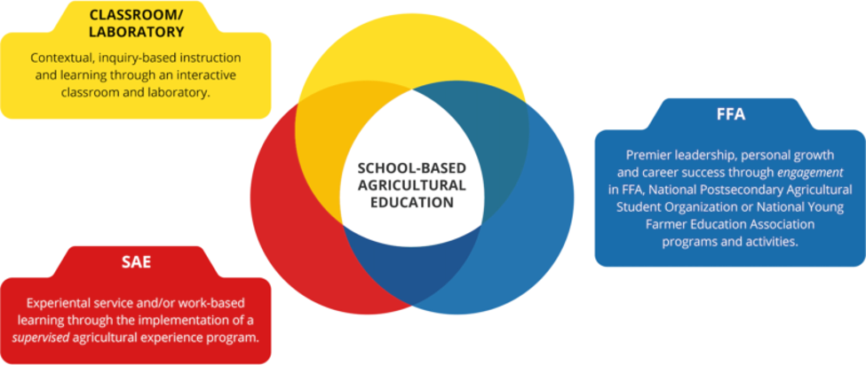

*FFA membership is affiliate in Pennsylvania. Anyone that takes an agriculture course is automatically an FFA member.

For a student to be considered a completer of the Agricultural Production Program, they must complete the following sequence of courses and pass the NOCTI Exam during their senior year. Students must also earn at least an 80% in the following courses.

Course Name | Credits | Hours
SAE I | 1.0 | 150
SAE II | 1.0 | 150
SAE III | 1.0 | 150
SAE IV | 1.0 | 150
Introduction to Agriculture | 0.5 | 60
Animal Studies | 0.5 | 60
Welding | 0.5 | 60
Power and Machinery | 0.5 | 60
Wildlife and NRM | 0.5 | 60
Forestry | 0.5 | 60
Plant and Soil Studies | 0.5 | 60
Biotechnology | 0.5 | 60
Ag Leadership | 0.5 | 60
Food in Agribusiness | 0.5 | 60
Bio Ag Science | 1.0 | 120
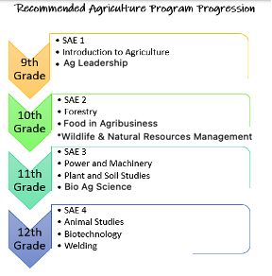

SUPERVISED AGRICULTURAL EXPERIENCE (SAE) I, II, III, IV
PREREQUISITE- (Preapproved by teacher) GRADES 9,10,11,12
CREDIT 1.0 #708/709/710/711
Students will be required to spend at least 20 hours per quarter, independently, working on their SAE. One meeting each quarter will be scheduled to meet with the agricultural instructor to review student progress. A supervised agricultural experience project is required of all students as a part of his or her agricultural production program. Supervised Agricultural Experience programs (SAE), which increase in scope and in depth as student’s progress through school, will aid in achieving successful employment and higher degrees in the FFA. The student will be required to maintain a record book of their SAE. Types of SAE are as follows:

- AGRICULTURAL ENTREPRENEURSHIP
- Owning an agricultural business, mainly production-based
- AGRICULTURAL PLACEMENT
- Job/internship either paid or unpaid for a business or person
- AGRICULTURAL RESEARCH
- A research project based on solving a problem
- FOUNDATIONAL (ONLY 8TH/FRESHMAN)
- Career interest and exploration
- Employability skills
- Personal Finance Management
- Agricultural Literacy
- Workplace Safety
- MISCELLANEOUS
There are other options for projects, but they must be discussed with the teacher.
BIO-AG SCIENCE
PREREQUISITE-NONE GRADES 10,11,12
CREDIT 1.0 #700
Bio-Ag is a science-technology-society course which also includes the exploration of career potentials. This course incorporates the history, development, and ecological effects of agriculture, drawing upon all four major sciences with an emphasis on plant science. The activities for this course involve societal impact of agriculture and horticultural/landscaping projects for the school environment.

FORESTRY
PREREQUISITE-NONE GRADES 9,10,11,12
CREDIT 0.5 #705
This course will cover identification of trees, diseases, measurements, lumber uses, growth and insect control. Students will spend some time in wood lot doing measurement work, identification and disease research. Students will be required to have an SAE project in lieu of a final and homework.

WELDING
PREREQUISITE-NONE GRADES 9,10,11,12
CREDIT 0.5 #706
The course will include classroom instruction in welding theory and practice as well as practical experience. Much of the time will be spent on assigned jobs designed to increase the students’ skill level as he or she moves from one job to another. After students have completed the assigned jobs, they will have the option to complete a welding project. It is recommended that students wear quality leather boots or shoes with insulated soles and jeans without holes or frayed cuffs. Students will be required to have an SAE project in lieu of a final and homework. A fee is required for the purchase of materials. Fees are set at the beginning of each school year.

WILDLIFE AND NATURAL RESOURCE MANAGEMENT
PREREQUISITE-NONE GRADES 9,10,11,12
CREDIT 0.5 #707
Part of this class will be spent on the ecology of game and non-game wildlife in Pennsylvania. Other topics covered will include water pollution, water use planning, air pollution, soil management and freshwater fishery management. Students will spend some time doing outdoor work. Students will be required to have an SAE project in lieu of a final and homework.

POWER AND MACHINERY
PREREQUISITE-NONE GRADES 9,10,11,12
CREDIT 0.5 #712
Outdoor power equipment technology is a study of internal combustion engines up to 25 horsepower. It includes theory and the disassembly and repair of both two and four stroke engines. Students work on school-owned engines. Some time will be allowed for repair of student-owned engines. The course will cover both classroom theory and hands-on experience on small gas and/or small diesel internal combustion engines. The course will include troubleshooting and repair of two and four stroke engines, from lawn mowers to chain saws. Students will be required to have an SAE project in lieu of a final and homework.

INTRODUCTION TO AGRICULTURE EDUCATION
PREREQUISITE-NONE GRADES 9,10,11,12
CREDIT 0.5 #713
Introduction to Agricultural Education will cover the purpose, structure, and function of the FFA and agricultural education. Each student will be required to begin a supervised agricultural experience (SAE) project, which will be maintained and improved throughout high school.

ANIMAL STUDIES
PREREQUISITE-NONE GRADES 9,10,11,12
CREDIT 0.5 #714
Animal Science includes a study of genetics, feeding, housing and marketing of common domestic animals, as well as meat processing. Breed identification and animal judging will be studied during this course. Current advances in animal technology are also studied. Students will be required to have an SAE project in lieu of a final and homework.

PLANT AND SOIL STUDIES
PREREQUISITE-NONE GRADES 9,10,11,12
CREDIT 0.5 #717
Plant and Soil Science will cover the relationship between agricultural crop production and soil management. Students will learn about land use, soil testing, erosion control, nutrient management, pest management and crop production. Students will learn how to effectively use the Agronomy Guide and Soil Survey to manage both agricultural and non-agricultural lands. Students will be required to have an SAE project in lieu of a final and homework.

BIOTECHNOLOGY
PREREQUISITE-NONE GRADES 9,10,11,12
CREDIT 0.5 #718
Biotechnology is using modern technology to change or modify, with the goal of improving, the biological structure of living organisms or to create new organisms, for specific positive uses and/or to provide beneficial processes, products, or services to consumers/businesses/society. This class will focus on how biotechnology is used to improve production of plant and animal agricultural products. We will also explore how biotechnology is utilized in the food science industry. Students will be required to have an SAE project in lieu of a final and homework.

FOOD IN AGRIBUSINESS
PREREQUISITE-NONE GRADES 9,10,11,12
CREDIT 0.5 #719
Food in Agribusiness will cover food safety and how microorganisms play into food safety. We will also discover common food constituents and the process that agricultural products take from farm to table. In addition, we will focus on food marketing. Students will be required to have an SAE project in lieu of a final and homework.

AGRICULTURAL LEADERSHIP
PREREQUISITE- NONE GRADES 11, 12
CREDIT 0.5
This course will challenge Agriculture, Food, and Natural Resources (AFNR) students to use higher level thinking skills, develop leadership abilities, employ standard research principles, and communicate agriculture positions effectively with all stakeholders and present them with opportunities in the agriculture industries. Topics will include research, verbal and written communications, media, agriculture policy and research, and human relations. Other topics may include problem solving and decision making and teamwork skills. An essential part of this course will be leadership activities, parliamentary procedure, and public speaking. Upon successful completion of this course, students will have acquired entry-level skills for employment and be prepared for postsecondary education.

NORTHERN TIER CAREER CENTER

AVAILABLE TO STUDENTS IN GRADES 11 AND 12 who have successfully earned 13 credits by the end of their 10th grade year. Also open to students in grade 10 looking to enter the cosmetology program who have successfully earned 6 credits by the end of their 9th grade year. During the school year, Seniors who have failed core courses may be held back from attending NTCC.

The need on the part of Troy High School students for training in vocational-technical areas is best seen in the number of students who apply each year for consideration for relatively few openings available to the vocational technical programs. Students who are interested in being considered for one of these programs should complete the NTCC application and return it to their counselor as early as possible after course selection begins. Students who have failed a required subject may not be able to graduate in four years unless the failed subject is made up in summer school.

Students attend the Northern Tier Career Center in Towanda on a half-day basis every day all year. This enables students to receive training in their vocational-technical subject while completing their academic work required for graduation. Free transportation from the high school to the Northern Tier Career Center is provided each day during the school year.

Some courses at the career center require a student to purchase special uniforms or clothing. This is at the student’s expense.

Selection and assignment to the career center and/or any vocational program at the Troy High School are not made on the basis of race, creed, handicap, national origin nor any other reason which would be viewed as discriminatory.

For more complete program description of the course offerings, see the northern Tier Career Center Vocational Education Course Guide. (available in the guidance office)

The Students Occupationally & Academically Ready (SOAR) Program is a Pennsylvania Department of Education approved, Career & Technical Education Program of Study that credits skills and tasks learned at the secondary school (high school) level to a postsecondary (college) degree, diploma or certification program. SOAR programs prepare today’s student for High Priority Occupations which are tomorrow’s high demand and high wage careers. For more information about specific SOAR Programs, use this link:
http://www.education.state.pa.us/protal/server.pt/community/programs_of_study/7686

PCNOW Enrollment offered through Pennsylvania College of Technology:
https://k12.pct.edu/penncollegenow/school.htm?id=24

FOR ALL PROGRAMS STUDENTS EARN 4 CREDITS EACH YEAR THEY ATTEND THE NORTHERN TIER CAREER CENTER.

The following programs are available at the Northern Tier Career Center:

DIVERSIFIED OCCUPATIONS– ONE YEAR, SENIORS ONLY
GRADE 12 #182
This opportunity is available to SENIORS who are not enrolled in another NTCC program and allows students with specific career objectives in pathways that are not offered at NTCC to gain related experience for credit. Students complete theory classes through NTCC, including employability, career development, workplace readiness, technical skills, and safety. Students complete their remaining hours (minimum 15 hours per week) through paid part-time on-the-job experience at training sites, where they will develop skills in accordance with their individual training plans. Students will complete the NOCTI: 21st Century Skills for Workplace Success.
Industry Credential Opportunities:
CareerSafe: OSHA Safety
National Safety Council: Forklift Operator Certification

CONSTRUCTION TRADES

BUILDING CONSTRUCTION TRADES – 900 Hours
GRADE 11 #157
GRADE 12 #167
This program of study covers construction and remodeling of buildings including carpentry, concrete, masonry, painting, drywall, cabinetry, roofing, plumbing, electrical, stairs, and interior/exterior finishes. Students study and practice all phases of building construction, from layout of site, foundation and wall construction, to roof framing and interior trim.
Industry Credential Opportunities:
OSHA: 10-hour Safety Course, Construction
National Safety Council: Forklift Operator Certification
Penn College NOW – Dual Enrollment with Penn College of Technology: BCT 103, 109 & 234 (10 credits offered)

MECHANICAL TRADES (HVAC-Plumbing-Electrical) – 900 Hours
GRADE 11 #173
GRADE 12 #183
This Heating, Ventilation & Air Conditioning (HVAC) program combines classroom and practical learning experiences and prepares individuals to apply technical knowledge and skills to install, repair, and maintain home and business heating, air conditioning, basic plumbing, electrical, and refrigeration systems. Students will gain experience by working on equipment that is used daily in their own homes, such as furnaces, water heaters, electrical appliances, and air conditioning units.
Industry Credential Opportunities:
OSHA: 10-hour Safety Course, Construction
\Air Conditioning, Heating & Refrigeration Institute: EPA 608
National Safety Council: Forklift Operator Certification
Penn College NOW – Dual Enrollment with Penn College of Technology: ACR 111 (5 credits offered)

HEALTH CARE

HEALTH ASSISTANT/PRE-NURSING – 900 Hours
GRADE 11 #162
GRADE 12 #172
This course allows the student to advance at their own rate and allows for individuality in the choice of a specific career objective and provides skills for Medical Assistant, Nursing Assistant, and Dental Assistant. Introduction to EKG, Phlebotomy, Occupational and Physical Therapies are included. This course is for the student looking to further their education in health care as a Registered Nurse, LPN, OT, PT and other health care related fields. After completion of the nursing assistant curriculum, students are eligible to take the state exams (written & skill) for placement on the registry for long-term care nursing assistants. Clinical experiences may accompany portions of this course.
Industry Credential Opportunities:
Pennsylvania Department of Health: Nurse Aide Registry
American Red Cross: First Aid and CPR
DVM-Instructional Systems: Dean Vaughn Learning Systems in Medical Terminology
OSHA: 10-hour Safety Course, Healthcare
Penn College NOW – Dual Enrollment with Penn College of Technology: MTR 104 (3 credits offered)

HOSPITALITY

FOOD PRODUCTION AND MANAGEMENT – 900 Hours
GRADE 11 #161
GRADE 12 #171
This course is designed to provide the student with the skills, knowledge, and attitudes necessary in food service and hospitality related careers. Specialized learning units include theory and work experience in the major areas of selection, purchasing, storage and preparation of ingredients, baking and desserts, restaurant management, and cold food preparation. The restaurant kitchen serves as the preparation laboratory, while the 40 seat restaurant provides experience in proper front-of-the house operations.
Industry Credential Opportunities:
National Restaurant Association: ServSafe Manager’s Certification
National Restaurant Association: ServSafe Allergen Certification
Penn College NOW – Dual Enrollment with Penn College of Technology: FHD 118 & FHD 137 (4 credits offered)

INFORMATION TECHNOLOGY

INFORMATION TECHNOLOGY – 900 Hours
GRADE 11 #193
GRADE 12 #194
This program prepares students to apply basic engineering principles and technical skills as they take the first step in pursuit of an IT career in cloud computing, network administration, mobility, security systems administration, programming, database management, and/or continuing education at a post-secondary institution. Taking a broad-spectrum approach, students will learn basic computer design and maintenance, security, networking, operating systems, IT operations, hardware and software problem diagnosis, troubleshooting, technical support, and web design. Students will gain the foundational knowledge and skills necessary to successfully pursue the post-secondary training and education that is required for most entry-level positions in IT.
Industry Credential Opportunities:
CompTIA: IT Fundamentals Certification
CompTIA: A+ Certification
Penn College NOW – Dual Enrollment with Penn College of Technology: EET 145 (4 credits offered)

HUMAN SERVICES

COSMETOLOGY – 1350 Hours (Tech Prep)
GRADE 10 #154
GRADE 11 #159
GRADE 12 #169
This is a state licensed course designed to provide the student with fundamentals needed to prepare for the state board examination. Instruction is provided in chemical textures, hair coloring and lightening techniques, haircutting and hair design, microdermabrasion, glycolic peels, facials, superfluous hair removal, styling eyebrows, pedicures, manicures, and nail art. Practical experience is gained by providing services through the operation of an on-site clinic for classmates, fellow NTCC students, and clients from the community.
Industry Credential Opportunities:
Pennsylvania State Board of Cosmetology: Cosmetologist
*1250 hours are required by the Pennsylvania State Board of Cosmetology to take the State Board exam. In order to obtain sufficient hours, students will need to enroll in their 10th grade year. Summer school is no longer offered for completion of hours.

TEACHER ACADEMY/EARLY CHILDHOOD EDUCATION – 900 Hours
GRADE 11 #151
GRADE 12 #152
This program provides instruction in the physical, emotional, intellectual, and social development of children. Aspects of teaching and working with children from birth to elementary school age are included, such as health, wellness, safety, growth, behavior, and developmental milestones. Students will learn to attend to children’s basic needs, organize activities, develop curriculum, prepare lesson plans, design and manage programs, and effectively deliver instruction in childcare, pre-school, and elementary settings. Theory in this course includes human development, psychology, ethical and professional responsibilities, communication, and the interaction of child, family, community, and schools. Clinical experiences will provide opportunities for students to develop the skills necessary to become successful future teachers and childcare providers while working directly with young children in childcare centers and schools.
Industry Credential Opportunities:
Child Development Associate (CDA) National Credential
American Red Cross: First Aid and CPR
College credit opportunities: Dual enrollment anticipated and currently being explored.

MANUFACTURING

MACHINE TOOL TECHNOLOGY – 900 Hours
GRADE 11 #177
GRADE 12 #178
The MTT program is designed to prepare students with the skills and experience necessary to pursue post-secondary education and training in machining and engineering pathways or obtain entry level employment in the metal products or manufacturing industry. Students will be trained in the conventional areas of industrial machine setup, operation, and maintenance, to include lathes, mills, drills, and grinders, as well as in Computer Numerical Control (CNC) machine setup, programming and operation. Students will develop skills in industry-related mathematics and CAD/CAM software applications, in addition to the use of tools, gauges, precision instruments, and blueprints. Machinists are in exceptionally high demand and the field includes careers in engineering, manufacturing, machine maintenance, tool and die, and fabrication.
Industry Credential Opportunities:
National Institute for Metalworking Skills, Inc. (NIMS)
OSHA: 10-hour Safety Course, General Contracting
National Safety Council: Forklift Operator Certification
Penn College NOW – Dual Enrollment with Penn College of Technology: MTT 118 & MTT 119 (8 credits offered)

WELDING TECHNOLOGY – 900 Hours
GRADE 11 #179
GRADE 12 #181
The Welding program is taught in a simulated work environment to help develop the hands-on experience, as well as theory and equipment and shop safety skills. The course is designed to equip students with skills and knowledge in shielded metal arc welding (SMAW), gas metal arc welding (GTAW), and flux core arc welding (FCAW), as well as blueprint reading and fabrication.
Industry Credential Opportunities:
American Welding Society: Level 1 Entry Welder Training
OSHA: 10-hour Safety Course, General Contracting
National Safety Council: Forklift Operator Certification
Penn College NOW – Dual Enrollment with Penn College of Technology: WEL114, WEL116, WEL120, WEL123, WEL124 & WEL129 (12 credits offered)

TRANSPORTATION

AUTOMOTIVE MECHANICS TECHNOLOGY
GRADE 11 #156
GRADE 12 #166
This program prepares individuals to apply technical knowledge and skills to the specialized area of automotive technology including engine diagnosis, engine repairs, heating & cooling systems, power train, brake suspension, steering systems, and computerized engine controls. Students study and practice all phases of engine repair and overhaul from diagnosis-problem solving to preventative maintenance.
Industry Credential Opportunities:
Pennsylvania Department of Transportation: Certified Safety Inspector Cat I, Cat II, Cat III
Environmental Protection Agency: 609 Motor Vehicle Air Conditioning Certification
Automotive Service Excellence (ASE): Entry-Level Certification
National Safety Council: Forklift Operator Certification

COLLISION REPAIR TECHNOLOGY
GRADE 11 #155
GRADE 12 #165
This program prepares individuals to apply technical knowledge and skills to the specialized areas of automotive reconstruction and restoration including panel replacement and repair, frame repair, plastic repair, refinishing, auto body related mechanics, automotive electricity, and estimating. Students study and practice all methods of auto body repair including the use of hand tools, welding practices, body and frame repair, refinishing processes, spray painting techniques, interior trim removal, upholstering, weather stripping, sheet metal repair, filler work, and plastic repair.
Industry Credential Opportunities:
Pennsylvania Department of Transportation: Certified Safety Inspector Cat I, Cat II, Cat III
Environmental Protection Agency: 6H Certification
ICAR: Non-Structural (14 certifications available)
National Safety Council: Forklift Operator Certification

DIESEL MECHANICS TECHNOLOGY
GRADE 11 #153
GRADE 12 #163
This program prepares individuals to apply technical knowledge and skills to the specialized maintenance and repair of trucks, buses, and other commercial and industrial vehicles. Instruction in diesel engine mechanics, suspension and steering, brake systems, electrical electronic systems, preventative maintenance inspections, drive trains, HVAC systems, and auxiliary equipment installation and repair is included.
Industry Credential Opportunities:
Pennsylvania Department of Transportation: Certified Safety Inspector Cat I, Cat II, Cat III
Automotive Service Excellence (ASE): Entry-Level Certification
Bendix: Brake Certification; MGM: Brake Certification
Environmental Protection Agency: 609 Motor Vehicle Air Conditioning Certification
National Safety Council: Forklift Operator Certification
Penn College NOW – Dual Enrollment with Penn College of Technology: DSM 119 & DSM 141 (4 credits offered)

